
Operating and Maintenance Manual

and Building Log Book for the

Mechanical Services Installation at

General Office Building
Reception Refurbishment
A N Other Contractors Ltd
123 High Road
London
E1 2AB

Tel: 020 7123 1234
Fax: 020 7123 5678

Volume One of One


SECTION

VOLUME ONE

ONE

TWO

THREE

FOUR

FIVE

SIX

SEVEN

EIGHT

NINE

TEN

ELEVEN

TWELVE
CONTENTS

DESCRIPTION
-

-

-

-

-

-

-

-

-

-

-

-
General Description of Installation

Plant Data Schedules

Emergency Procedures and First Aid

Health and Safety Information

Operating Procedures

Maintenance Schedules

Maintenance Instructions and Log Books

Fault Tracing Charts

Manufacturers' Literature

Test Certificates and Commissioning Data

Specialist Services Documentation

Record Drawings


SECTION ONE
GENERAL DESCRIPTION OF INSTALLATION


SECTION ONE

INDEX

ITEM
1.1

1.1.1
1.1.2
1.1.3
1.1.4
1.1.5
1.1.6
1.1.7
1.1.8
1.1.9
1.1.10
1.1.11
-

-
-
-
-
-
-
-
-
-
-
-
General Description of Installation
DESCRIPTION

PRELIMINARY ITEMS

Introduction
Document Revisions
Purpose of Each Section
Schedule of Abbreviations
Schedule of Services Identification
Specific Health and Safety Issues
Incoming Services Location
Emergency Telephone Numbers
Schedule of Project Team Members
Brief Description of Installation
Design Criteria

HEATING AND COOLING SYSTEMS

Air Conditioning System

MISCELLANEOUS SYSTEMS

Specialist Services
1.2

1.2.1
-

-
1.3

1.3.1
-

-
General Office Building, Reception Refurbishment
Section 1, Page 2


SECTION ONE

Title: Introduction

Category: Preliminary Items
General Description of Installation
Item: 1.1.1

Page: 1 of 1
The purpose of this operating and maintenance manual and building log book is to offer the personnel
concerned with the operation and maintenance of the services within the building, assistance in the
performance of their duties. It is intended that this manual will be used to assist skilled engineers,
experienced in the operation and maintenance of building services, to provide them with a comprehensive
working knowledge of the various systems installed within the project.

Although the manual functions as a complete entity, each section is self contained and provides
information on differing aspects of the installation. Familiarisation with all sections prior to formulating
an operating and maintenance regime will prepare the building maintenance personnel for the occasions
when a particular problem occurs.

The information, procedures and instructions contained herein are those appertaining at the time of
preparation and the date of issue. Changes arising in building usage, legislation, etc, will necessitate
revisions to be made in order to retain the manual's validity and usefulness. Any alterations to this
document (addition, revision or omission) should be recorded on the following page.

The information within this manual will allow maintenance to be carried out safely and reliably, as well
as providing important data upon which calculations may be made for design of alterations and/or
additions, should the need arise. It should be noted that this manual is not intended to supersede or conflict
with any standard maintenance/inspection routines already in use.

This manual has been based on the content suggested by the Building Services Research and Information
Association in their application guide AG 1/87.1 (Operating and Maintenance Manuals for Building
Services Installations). Where issued electronically the same organisation's guide BG 2/2004 (Computer
BasedOperatingandMaintenance Manuals)has been utilised(theirsuggested"PDFBasedSystem").This
manual has also been compiled to cater for other industry legislation requirements such as Health and
Safety Executive (CDM) and the Building Regulations (Part L2) et al.
Practical Completion:
Handover:
Defects Liability Period:
Author:
June 2007
June 2007
12 Months
Manual Version:
Date of Final Issue:
Author's Reference:
5.01.04
June 2007
xxxx
Office-Scope, 43 Leicester Road, Wanstead, London, E11 2DW
Tel: 020 8536 4060, Fax: 020 8536 4061
E-mail: <recipient>@office-scope.co.uk, Website: www.office-scope.co.uk

This manual is also available as a fully interactive electronic document suitable for direct use on a computer
For further details or to obtain a quotation, please contact the author with your requirements quoting the above reference number.
General Office Building, Reception Refurbishment
Section 1, Page 3

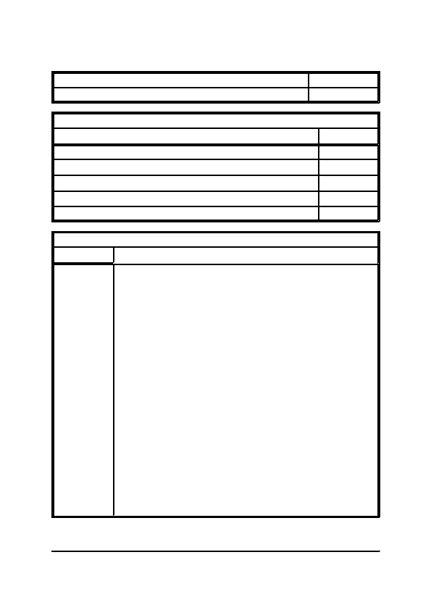
SECTION ONE

Title: Document Revisions

Category: Preliminary Items
General Description of Installation
Item: 1.1.2

Page: 1 of 1
Initial Production

Stage of Development (all dates refer to author)

Draft Copy Production Commenced

Draft Copy Issued

Comments Received, Information/Clarification Sought

Information/Clarification Received, Final Copy Production Commenced

Final Copy Issued
Date

21/5/2007

23/5/2007

25/6/2007

27/6/2007

28/6/2007
Date
Subsequent Revision History

Description of Revisions
General Office Building, Reception Refurbishment
Section 1, Page 4


SECTION ONE

Title: Purpose of Each Section

Category: Preliminary Items
General Description of Installation
Item: 1.1.3

Page: 1 of 1
Section One - General Description of Installation - This section contains a general description of each system,
together with other introductory information. The descriptions are intended to be read in conjunction with the Record
Drawings to aid the maintenance personnel in familiarising themselves within the installation, prior to formulating
an operating and maintenance programme.

Section Two - Plant Data Schedules - This section contains the technical data for each item of equipment extracted
from the manufacturers' literature and other sources to assist with the maintenance and possible replacement of faulty
items of equipment. Recommended stocked spares list, lubricants, special tools and equipment are also included.

Section Three - Emergency Procedures and First Aid - This section contains the procedures that should be
followed in the event of an emergency, together with the emergency call-out telephone numbers for the local utility
companies and basic first aid instructions.

Section Four - Health and Safety Information - This section contains check lists and safety procedures that should
be followed to ensure that the operation and maintenance of the installation is undertaken in a safe manner.

Section Five - Operating Procedures - This section contains all necessary operational procedures for the systems.
It is intended that the procedures are read in conjunction with the manufacturers' literature so that operational
procedures are extended beyond each item of equipment and cover the full system.

Section Six - Maintenance Schedules - This section contains schedules of maintenance tasks for each item of
equipment. It is intended for use in the formulation of a Planned Preventative Maintenance regime. The schedules
are intended to be read in conjunction with the manufacturers' literature for detailed maintenance instructions.

Section Seven - Maintenance Instructions and Log Books - This section contains various instructions and
procedures necessary when implementing an operating and maintenance regime, including risk assessments,
handling/disposal instructions, decontamination procedures and recommendations on the use and keeping of energy
usage and maintenance log books, together with sample log book documentation.

Section Eight - Fault Tracing Charts - This section contains charts to assist with the location of faults that occur
with systems. Once the appropriate faulty item of equipment has been located, the fault tracing chart within the
manufacturers' literature should be consulted to remedy the problem.

Section Nine - Manufacturers' Literature - This section contains the manufacturers' literature for each item of
equipment. This information should be used in conjunction with various sections as described above.

Section Ten - Test Certificates and Commissioning Data - This section contains the test certificates and
commissioning data that should be consulted when carrying out maintenance tasks, or fault tracing procedures, to
ensure the correct and efficient operation of each system.

Section Eleven - Specialist Services Documentation - This section contains the small independent manuals from
the specialist sub-contractors which contain all necessary operating and maintenance information.

Section Twelve - Record Drawings - This section contains a copy of each of the Record Drawings which should
be read in conjunction with the general descriptions and are intended to assist the maintenance personnel with the
familiarisation of the installation.
General Office Building, Reception Refurbishment
Section 1, Page 5

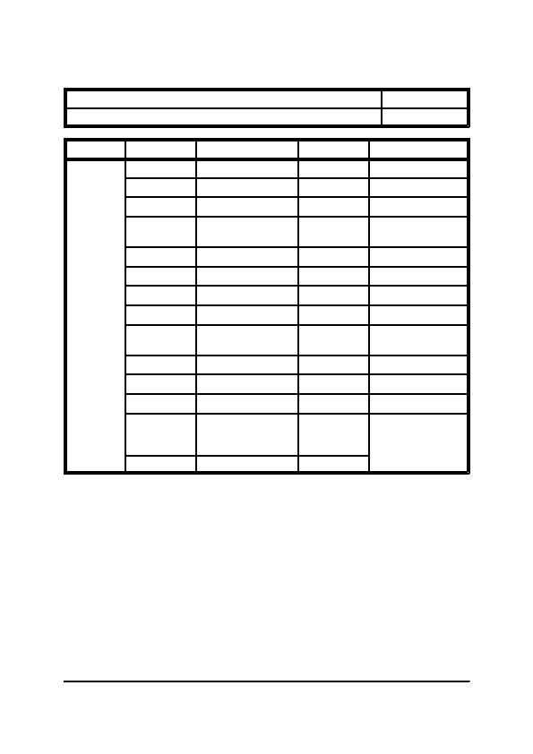
SECTION ONE

Title: Schedule of Abbreviations

Category: Preliminary Items
Type
General Description of Installation
Item: 1.1.4

Page: 1 of 2
Equipment
Abbreviation

AHU

FCU

SD

MD

SG

LSD

TG

RC

DRV

NRV

DC

GC
Meaning

Air Handling Unit

Fan Coil Unit

Smoke Damper

Motorised Damper

Supply Grille

Linear Slot Diffuser

Transfer Grille

Roof Cowl

Double Regulating
Valve

Non-Return Valve

Drain Cock

Gas Cock
Abbreviation

EF

VAV

FD

VCD

SD

EG

WL

IV

CS

STR

DX

SC
DCV
Double Check Valve
PRV
SV
Safety Valve
BV
Meaning

Extract Fan

Variable Air Volume

Fire Damper

Volume Control
Damper

Supply Diffuser

Extract Grille

Weather Louvre

Isolating Valve

Commissioning Set

Strainer

Direct Expansion

Stop Cock

Pressure Relief Valve
or Pressure Reducing
Valve

Ball Valve
General Office Building, Reception Refurbishment
Section 1, Page 6

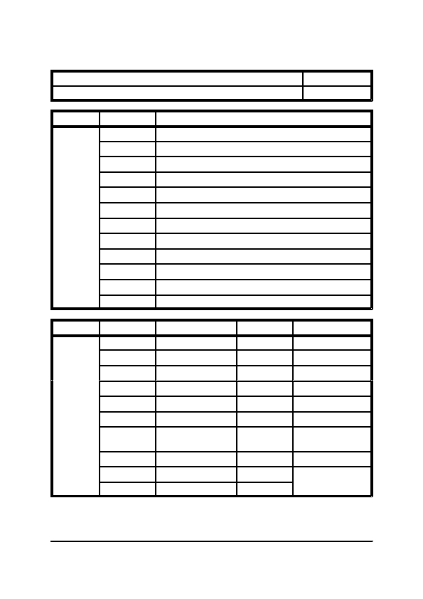
SECTION ONE

Title: Schedule of Abbreviations

Category: Preliminary Items
Type
General Description of Installation
Item: 1.1.4

Page: 2 of 2
Systems
Abbreviation

LTHW

MTHW

CHW

VRV

MWS

CWDS

HWS

BMS

F&R

CF

OV

F&E
Meaning

Low Temperature Hot Water

Medium Temperature Hot Water

Chilled Water

Variable Refrigerant Volume

Mains Water Service

Cold Water Down Service

Hot Water Service

Building Management System

Flow and Return

Cold Feed

Open Vent

Feed and Expansion
Type
Units
Abbreviation

oC

wb

W

mm

kg

kPa

m 3/s

kg/h

rpm

V
Meaning

Degree Celsius

wet bulb

Watts

milli-metres

kilo grammes

kilo Pascals

cubic metres per
second

kilo grammes per hour

revolutions per minute

Volts, Voltage
Abbreviation

db

% RH

kW

m

Pa

m/s

kg/s

l/s

Hz

A
Meaning

dry bulb

Relative Humidity

kilo Watts

metres

Pascals

metres per second

kilo grammes per
second

litres per second

Hertz

Amps
General Office Building, Reception Refurbishment
Section 1, Page 7

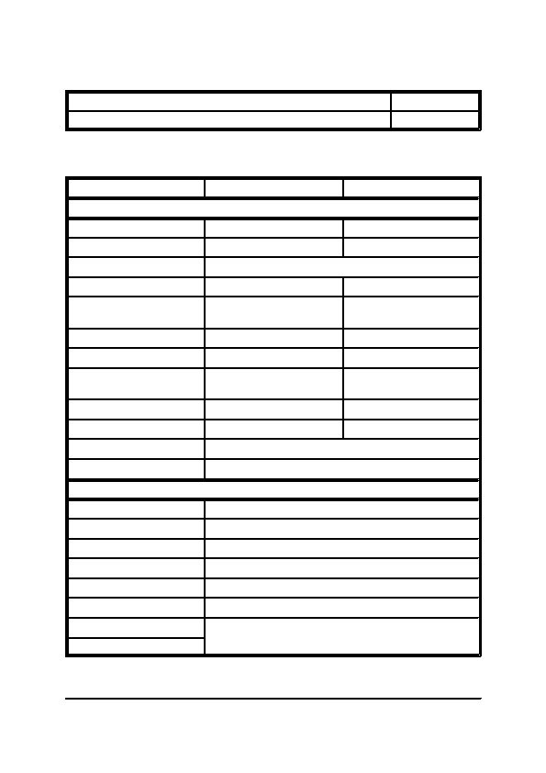
SECTION ONE

Title: Schedule of Services Identification

Category: Preliminary Items
General Description of Installation
Item: 1.1.5

Page: 1 of 1
The services installed on this project have been identified by coloured bands in accordance with BS 1710
(1984). The following table illustrates this colour code:-
Service
Coloured Strips
Mains Water

Natural Gas

Steam

Low Temperature Hot Water

Medium Temperature Hot
Water

Chilled Water

Refrigerant R22

Refrigerants
R134a/R407c/R410a

Cold Water Down Service

Hot Water Service

Drainage

Compressed Air
Basic Colour

PIPEWORK

Green

Yellow Ochre
Auxiliary Blue

Yellow
Silver Grey

Blue/Crimson/Blue

Crimson/Blue/Crimson
Green

Green
Green

Yellow Ochre

Yellow Ochre
White/Emerald Green/White

Sea-Green

Emerald Green
Green

Green
White/Blue/White

White/Crimson/White
Black

Light Blue
DUCTWORK

Green Triangle

Red/Blue Triangle

Yellow Triangle

Red Triangle

Blue Triangle

Grey Triangle

Brown Triangle

Yellow/Black Triangle
Fresh Air

Conditioned Air

Warm Air

Hot Supply Air

Cold Supply Air

Exhaust Air

Foul Air

Contaminated/Hazardous Air
General Office Building, Reception Refurbishment
Section 1, Page 8


SECTION ONE

Title: Specific Health and Safety Issues

Category: Preliminary Items
General Description of Installation
Item: 1.1.6

Page: 1 of 1
The following information is a summary of the key Health and Safety issues regarding the project covered
by this document. It is imperative that the main Health and Safety section later within this document and
the main project Health and Safety File are fully consulted.

Residual Risks

The project has been designed to avoid there being any residual risks.
Special Access Requirements

The project has been designed to avoid the need for any special access requirements.
Special Maintenance Considerations

The project has been designed to avoid the need for any special maintenance considerations.
General Office Building, Reception Refurbishment
Section 1, Page 9


SECTION ONE

Title: Incoming Services Location

Category: Preliminary Items

The main incoming services are located in the following locations:-
Gas

Water

Electricity
-

-

-
General Description of Installation
Item: 1.1.7

Page: 1 of 1
Not applicable to the contract covered by this manual

Not applicable to the contract covered by this manual

Refer to electrical manual.
General Office Building, Reception Refurbishment
Section 1, Page 10


SECTION ONE

Title: Emergency Telephone Numbers

Category: Preliminary Items

The following telephone numbers are for emergency use only:-
Gas

Water and Sewage

Electricity

Police
Fire Brigade
Ambulance
-

-

-
Transco

Thames Water

EDF Energy (London)
General Description of Installation
Item: 1.1.8

Page: 1 of 1
-

-

-
0800 111999

0800 714614

0800 028 0247
-
Emergency Services Operator
-
999
General Office Building, Reception Refurbishment
Section 1, Page 11

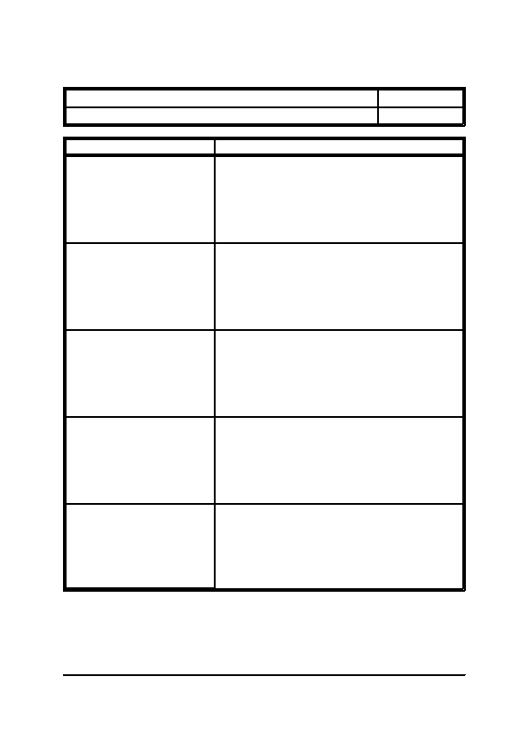
SECTION ONE

Title: Schedule of Project Team Members

Category: Preliminary Items

Project Team Role
General Description of Installation
Item: 1.1.9

Page: 1 of 2
Company

A N Other Client Ltd
123 High Road
London
E1 2AB

Tel: 020 7123 1234
Fax: 020 7123 5678

A N Other Employers Agent Ltd
123 High Road
London
E1 2AB

Tel: 020 7123 1234
Fax: 020 7123 5678

A N Other Architect Ltd
123 High Road
London
E1 2AB

Tel: 020 7123 1234
Fax: 020 7123 5678

A N Other Planning Supervisor Ltd
123 High Road
London
E1 2AB

Tel: 020 7123 1234
Fax: 020 7123 5678

A N Other Consultant Ltd
123 High Road
London
E1 2AB

Tel: 020 7123 1234
Fax: 020 7123 5678
Client
Employers Agent
Architect, Project Manager and
Contract Administrator
Planning Supervisor
Property Consultant
General Office Building, Reception Refurbishment
Section 1, Page 12


SECTION ONE

Title: Schedule of Project Team Members

Category: Preliminary Items

Project Team Role
General Description of Installation
Item: 1.1.9

Page: 2 of 2
Consultant Engineer
Main Contractor
Services Contractor
Company

A N Other Consultant Ltd
123 High Road
London
E1 2AB

Tel: 020 7123 1234
Fax: 020 7123 5678

A N Other Builder Ltd
123 High Road
London
E1 2AB

Tel: 020 7123 1234
Fax: 020 7123 5678

A N Other Contractor Ltd
123 High Road
London
E1 2AB

Tel: 020 7123 1234
Fax: 020 7123 5678
General Office Building, Reception Refurbishment
Section 1, Page 13


SECTION ONE

Title: Brief Description of Installation

Category: Preliminary Items
General Description of Installation
Item: 1.1.10

Page: 1 of 1
The following is an outline description of the services installed under the contract covered by this
document; for a full description of each system reference should be made to the following pages.

Heating and Cooling Systems
a)
A direct expansion heat pump split air conditioning system consisting of a void mounted ducted
internal unit which is connected to an air cooled condensing unit located on the roof.
Specialist Services

The contract covered by this document also encompassed various specialist services/systems as detailed
below, whichweresupplied,installed,testedandcommissionedby thespecialistsub-contractorindicated.
For full information relating to each system reference should be made to the self-contained specialist
manuals located within Section Eleven.

Mechanical Services Control System - A N Other Controls Company Ltd
General Office Building, Reception Refurbishment
Section 1, Page 14


SECTION ONE

Title: Design Criteria

Category: Preliminary Items

The following criteria were used during the design of the installation:-

External Conditions
Summer Temperature
Winter Temperature

Internal Conditions

Summer Temperature
Winter Temperature
-
-
General Description of Installation
Item: 1.1.11

Page: 1 of 1
31.0 oC db, 21.0 oC wb
-4.0 oC saturated
-
-
22.0 C +/ 2.0 oC, No Humidity Control
21.0 C +/ 2.0 oC, No Humidity Control
-
o
-
o
General Office Building, Reception Refurbishment
Section 1, Page 15


SECTION ONE

Title: Air Conditioning System

Category: Heating and Cooling Systems
General Description of Installation
Item: 1.2.1

Page: 1 of 1
A direct expansion heat pump split air conditioning system has been installed to provide both heating and
cooling to the Reception. The internal unit is void mounted above the reception desk and incorporates a
washable panel filter, a direct expansion heating/cooling coil and a direct driven centrifugal fan unit. Air
is drawn into the unit from the false ceiling void via a shadow gap in the ceiling, heated or cooled as
required and supplied back to the space via ranges of galvanised steel spiral ductwork which serve plenum
boxes located above a shadow gap on the opposite side of the space.

Liquid and suction refrigeration pipework extends from the internal unit to run through the false ceiling
void of the ground floor on a series of galvanised steel cable tray. The pipework then enters a building
services riser shaft where it rises through the building onto the roof and connects onto an air cooled
condensingunit.Thecondensingunitincorporatesadirect driven propeller condenserfanandarefrigerant
compressor.

The internal unit is controlled under the dictates of a return air sensor located within the return air path.
Condensate from the internal unit discharges into a gravity condensate drain run within the false ceiling
void which, in turn discharges into the existing above ground drainage system.

The pipework is insulated with a closed cellular foam insulation in order to reduce heat gain to the system
and vapour sealed to prevent the formation of condensation on the pipe surface.

For the locations of the equipment and the routes of the pipework reference should be made to the Record
Drawings contained within Section Twelve.
General Office Building, Reception Refurbishment
Section 1, Page 16


SECTION ONE

Title: Specialist Services

Category: Miscellaneous Systems
General Description of Installation
Item: 1.3.1

Page: 1 of 1
The contract covered by this document also encompassed various specialist services/systems as detailed
below, whichweresupplied,installed,testedandcommissionedby thespecialistsub-contractorindicated.
For full information relating to each system reference should be made to the self-contained specialist
manuals located within Section Eleven.

Mechanical Services Control System - A N Other Controls Company Ltd
General Office Building, Reception Refurbishment
Section 1, Page 17


SECTION TWO
PLANT DATA SCHEDULES


SECTION TWO

INDEX

ITEM
2.1

2.1.1
2.1.2
2.1.3
2.1.4
2.1.5
-

-
-
-
-
-
Plant Data Schedules
DESCRIPTION

MISCELLANEOUS ITEMS

Directory of Manufacturers
Spare Parts Policy
Recommended Stocked Spares
Lubricants
Special Tools and Equipment

HEATING AND COOLING SYSTEMS

Air Conditioning Units
2.2

2.2.1
-

-
General Office Building, Reception Refurbishment
Section 2, Page 2


SECTION TWO

Title: Directory of Manufacturers

Category: Miscellaneous Items
Name

A N Other Controls
Company Ltd
Plant Data Schedules
Item: 2.1.1

Page: 1 of 1
Address

123 High Road
London
E1 2AB

Tel: 020 7123 1234
Fax: 020 7123 5678

Orbital One
Unit 8 & 9 Green Street
Green Road
Dartford
Kent
DA1 1QG

Tel: 01322 628080
Fax: 01322 628081
Mitsubishi Electric
Europe Ltd
Equipment Supplied

Mechanical Services Control
System
Air Conditioning Units
General Office Building, Reception Refurbishment
Section 2, Page 3


SECTION TWO

Title: Spare Parts Policy

Category: Miscellaneous Items
Plant Data Schedules
Item: 2.1.2

Page: 1 of 1
A majority of the manufacturers' literature detail a full parts list, commonly with exploded view diagrams,
however, these lists are not intended to be interpreted as spares which should be stocked, rather a list of
the part numbers should a spare need to be ordered.

The determination of what spares at what quantities should be stocked will depend upon a number of
factors, including:-
i)
ii)
iii)
iv)
v)
The degree of in house or sub-contracted maintenance.
The economic factors.
The implications of system failure to the occupiers of the premises.
The level of back-up or redundancy offered by the systems.
The lead time of spares.
In order to determine the list of spares which should be stocked the following questions should be
considered.
1)
2)
3)
What parts of the system are consumable and will require routine replacement for the safe
and efficient operation of the system. Such items include filters, drive belts, fuses and
lamps.
What systems are critical to the operation of the business, consideration should be given
to the stocking of spare motors for such systems. Particularly critical systems will usually
have a certain level of redundancy designed into the system, commonly in the form of run
and standby fans/pumps, but occasionally with 100% system backup. In such situations
the stocking of spare motors may not be necessary.
What systems are less critical but which involve extended lead times for delivery of
spares.
Once a list of which items need to be stocked has been established, consideration needs to be given to the
quantity of stock to be held. Important points include:-
a)
b)

c)
d)
The shelf life of spares, for instance drive belts generally have an expiry date.
How often will it be necessary to order new items, the disposable panel filters in
ventilation systems may need to be changed every two to three months.
How much storage space is available.
Is secure space available for the storage of high value items.
The following section details the minimum level of spares that are recommended to be stocked, to this
should then be added the additional items determined as a result of the consideration of the above factors.
General Office Building, Reception Refurbishment
Section 2, Page 4


SECTION TWO

Title: Recommended Stocked Spares

Category: Miscellaneous Items
Plant Data Schedules
Item: 2.1.3

Page: 1 of 1
The equipment installed on this project do not incorporate any of the following items:-
i)
ii)
iii)
Consumable parts
Parts which break easily
Parts which involve long delivery periods
therefore, there is no requirement for the stocking of spares on such grounds.
General Office Building, Reception Refurbishment
Section 2, Page 5


SECTION TWO

Title: Lubricants

Category: Miscellaneous Items

There is no plant and equipment on this project which require lubrication.
Plant Data Schedules
Item: 2.1.4

Page: 1 of 1
General Office Building, Reception Refurbishment
Section 2, Page 6


SECTION TWO

Title: Special Tools and Equipment

Category: Miscellaneous Items
Plant Data Schedules
Item: 2.1.5

Page: 1 of 1
Beyond those tools found within a "standard" tool box very few special tools or equipment are necessary
to carry out the operation and maintenance of the systems covered by this manual. Such additional items
are as follows:-
Special Tools

• No special tools.
Equipment
•
•
•
•
•
Inclined manometer
Vane anemometer
Sling psychrometer
RPM strobe light
Electrical multi-meter
General Office Building, Reception Refurbishment
Section 2, Page 7


SECTION TWO

Title: Air Conditioning Units

Category: Heating and Cooling Systems

Internal Unit

General - Manufacturer
-

-

-
Model Number

Type

Duty
Plant Data Schedules
Item: 2.2.1

Page: 1 of 2
-
-

-
Cooling

Heating
-

-
Air Volume

Dimensions
-

-

-
Length

Width

Height
-

-

-
Weight

Refrigerant Type

Electrical Supply
-

-

-

-

-

-

-

-

-

-

-
Mitsubishi Electric
Europe

PEAD-RP71EA

Ceiling Concealed

6.4 kW

6.8 kW

25.0 m 3/min

1070 mm

740 mm

307 mm

44.0 kg

R410a

240 volts
1 phase
50 Hz
General Office Building, Reception Refurbishment
Section 2, Page 8


SECTION TWO

Title: Air Conditioning Units

Category: Heating and Cooling Systems

External Unit

General - Manufacturer
-

-
Model Number

Dimensions
Plant Data Schedules
Item: 2.2.1

Page: 2 of 2
-
-

-

-
Length

Width

Height
-

-
Weight

Refrigerant Type
-

-
Type

Charge
-

-

-
Starting Current

Full Load Current

Electrical Supply
-

-

-

-

-

-

-

-

-

-
Mitsubishi Electric
Europe

PUHZ-RP71VHA

950 mm

360 mm

943 mm

75.0 kg

R410a

3.5 kg

5.0 amps

10.17 amps

240 volts
1 phase
50 Hz
General Office Building, Reception Refurbishment
Section 2, Page 9


SECTION THREE
EMERGENCY PROCEDURES AND FIRST AID


SECTION THREE

INDEX

ITEM
3.1

3.1.1
3.1.2
3.1.3
3.1.4
-

-
-
-
-
Emergency Procedures and First Aid
DESCRIPTION

EMERGENCY PROCEDURES

Introduction
Failure of Electrical Supply
Refrigerant Leaks
Fire

FIRST AID PROCEDURES

Principles and Practice
Life Saving Measures
Emergency Situations
Dressings
Treatment for Electric Shock
Further Reading
3.2

3.2.1
3.2.2
3.2.3
3.2.4
3.2.5
3.2.6
-

-
-
-
-
-
-
General Office Building, Reception Refurbishment
Section 3, Page 2


SECTION THREE

Title: Introduction

Category: Emergency Procedures
Emergency Procedures and First Aid
Item: 3.1.1

Page: 1 of 1
The emergency procedures are intended as a guide only, each emergency situation that arises has to be
taken in the light of its degree of severity and the conditions prevailing at the time.

When an emergency situation is encountered, it is imperative that calm prevails. Measures and actions
taken when made in haste or panic, will not only in all probability be wrong, but could spread panic in
other people.

A few minutes spent in rationalising the situation and planning your campaign of actions, even in an
emergency of the utmost gravity, will save time and possibly injury in the long run.

Never take risks in an emergency, for a risk can turn a minor emergency into a major one. The safety of
personnel must always come first.

Any temporary repairs effected or arrangements made during or after an emergency must be corrected as
soon as it is practically possible.
General Office Building, Reception Refurbishment
Section 3, Page 3


SECTION THREE

Title: Failure of Electrical Supply

Category: Emergency Procedures
Emergency Procedures and First Aid
Item: 3.1.2

Page: 1 of 1
Description: This describes the general steps to take on failure of the electrical supply.

Notes:
Step

1
Action

Ascertain whether the failure is local or general.
2
If failure is local, check whether fuses have
blown, or circuit breaker has tripped.
3
If failure is general, check position of lifts (if
applicable) and hand winch to nearest lower
floor.
Notes

Check whether general lighting and
power is affected.

Replace with correct size fuse, or reset
circuit breaker as required, after
checking cause of failure and retesting
the circuit.

Isolate lift supply prior to winching.

Inform local electricity company of
failure.

Place "Lift Out of Service" notices on
all floors.
4
5
Repairs to electrical switchgear and cables
should only be undertaken by a fully qualified
electrician.

If the failure is general, isolate the supply to
items of plant until the supply is restored.
General Office Building, Reception Refurbishment
Section 3, Page 4

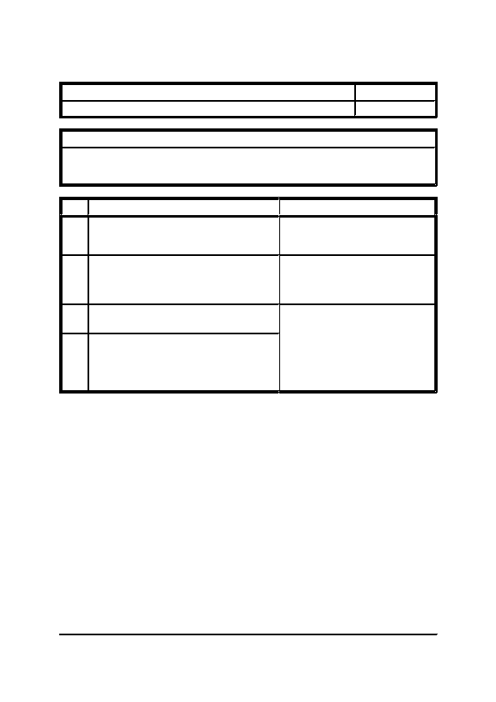
SECTION THREE

Title: Refrigerant Leaks

Category: Emergency Procedures
Emergency Procedures and First Aid
Item: 3.1.3

Page: 1 of 1
Description: This describes the action to take in the event of a refrigerant leak.

Notes:
1. The refrigerant that leaks out will most probably be in the form of vapour, therefore the source of
the leak will be hard to find out without proper leak detection equipment.
Step
1
Action

Shut down and electrically isolate the affected
items of plant. Check that all doors of control
panels are properly closed.
Notes
2
Evacuate all personnel from the vicinity and call
in Refrigeration Engineers.
There must not be any smoking or
flames present as they will cause the
refrigerant to break down into highly
toxic gases.
3
4
Ensure that all doors to the room are securely
shut.

It should be remembered that refrigerants are
harmful to the Ozone Layer and therefore must
be disposed of in accordance with the
requirements of the local Environmental Health
Officer.
General Office Building, Reception Refurbishment
Section 3, Page 5

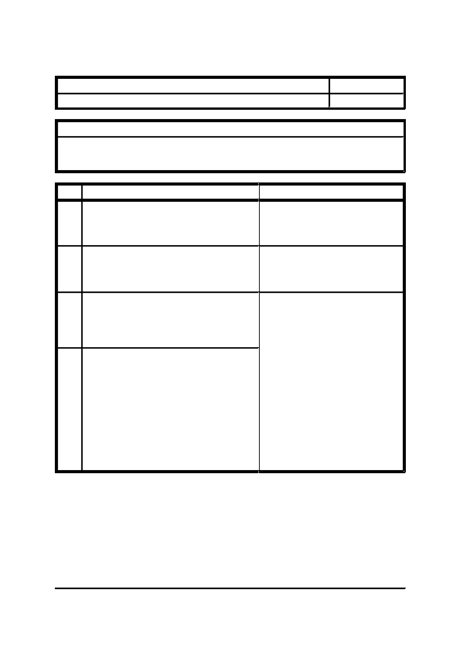
SECTION THREE

Title: Fire

Category: Emergency Procedures
Emergency Procedures and First Aid
Item: 3.1.4

Page: 1 of 1
Description: This describes the action to take in the event of fire breaking out.

Notes:
1. Always inform the Fire Brigade should fire break out, and never attempt to fight it alone.
2. Never use a liquid type extinguisher to fight electrical fires.
Step
1
2
3
Action

Under most conditions occurrence of fire will be
picked up by the automatic fire detection
equipment. However, for certain locations the
manual call points should be activated.

Having ascertained the location of the fire, check
out its severity and if local and contained, use
fire fighting equipment provided - hand
extinguishers, hose reels, etc.

If the fire cannot be extinguished within a few
minutes, the general alarm should be initiated
and the FIRE BRIGADE contacted. All plant
should be shut down.
Notes
Check the fire alarm is genuine and not
a fault.
4
The fire should be contained as far as possible,
without personal risks taken, until the fire
brigade has arrived.
The standard fire drill should be put
into operation. Check that all personnel
are evacuated from the immediate and
surrounding areas first, then from the
building completely.

Check that all windows in the
immediate and surrounding areas are
closed, together with all fire doors.

Beware of toxic fumes when in the
vicinity of fire. These are not
necessarily visible. If in any doubt,
abandon the attempt to fight the fire.

Remember, the gases are buoyant due
to heat, therefore, the air is more
breathable nearer floor level.
General Office Building, Reception Refurbishment
Section 3, Page 6


SECTION THREE

Title: Principles and Practice

Category: First Aid Procedures

a) - Definition
Emergency Procedures and First Aid
Item: 3.2.1

Page: 1 of 2
First Aid is based on the principles of practical medicine and surgery; a knowledge of the subject in case
of accident or sudden illness, enables trained persons to give such skilled assistance as will preserve life,
promote recovery and prevent the injury or illness becoming worse until medical aid has been obtained.

NOTE: Medical Aid indicates treatment by a Doctor.

First Aid consists of simple measures that anyone can learn but if carried out correctly, quickly, gently
and as early as possible, they can be life-saving.

b) - First Aider's Responsibility

This ends when handed over to the care of a Doctor, a Nurse or other responsible person, but not until they
have taken over the whole responsibility for the case. The First Aider should not leave until he has made
his report to the Doctor or other responsible persons and has ascertained whether he could be of any
further help.

First Aid, in general, is limited to the assistance rendered at the time of the emergency, with such material
as is available and often extensive improvisation will be necessary.

Remember at all times the importance of COMMON SENSE in First Aid, as an addition to the actual
knowledge of the subject. This section (and other First Aid Manuals) usually considers for treatment only
one condition at a time. However, in real life it will be found that serious accidents rarely produce a single
injury. Frequently, two injuries or more occur close together, so that the correct treatment of one may
interfere with the correct treatment of the other. One injury may require the casualty to be put on his back,
another that he should be in a coma or recovery position. In such a circumstance, the First Aider must
decide which injury is most serious, or needs the most urgent treatment and treat that one in the correct
way and then deal with the second injury as correctly as possible under the conflicting circumstances.
Often a casualty suffers from more than two injuries at the same time, which makes matters even more
difficult.

c) - The Scope of First Aid

This consists of three parts;
i)

ii)

iii)
Dealing with the situation, apart from the casualty.

Diagnosing what is the matter with the casualty and then giving the correct First Aid treatment.

Transferring of the casualty to a doctor, hospital or home and notifying those concerned about the
accident.
General Office Building, Reception Refurbishment
Section 3, Page 7


SECTION THREE

Title: Principles and Practice

Category: First Aid Procedures

In arriving at the diagnosis, the First Aider is guided by:
i)
Emergency Procedures and First Aid
Item: 3.2.1

Page: 2 of 2
ii)
iii)
The report furnished by persons present
(which includes the conscious casualty),
as to the cause of the injury or illness.

The account given by the casualty of their
own sensations and feelings.

The complete examination of the patient.
-
HISTORY
-

-
SYMPTOMS

SIGNS
d)
-
Priority in First Aid
Do first things first, quickly and methodically.

Check for danger.

Reassure the casualty and those around to lessen anxiety, whilst taking in the situation.

Ascertain from the casualty whether they are on any medication or have any medical conditions.

If breathing has stopped, start resuscitation.

Control visible bleeding.

Give priority to the individual with the most important injuries.

Give priority where several are injured to those who will benefit most by prompt treatment.

Guard against shock - and look for concealed bleeding.

Immobilise fractures.

Do not attempt too much - attend to the essential and prevent the condition from becoming worse.

Do not allow people to crowd around - they get in the way, and fresh air is essential.

Arrange early for careful conveyance of the casualty to Hospital or to a Doctor.
General Office Building, Reception Refurbishment
Section 3, Page 8


SECTION THREE

Title: Life Saving Measures

Category: First Aid Procedures

a) - Electrical Injuries
Emergency Procedures and First Aid
Item: 3.2.2

Page: 1 of 1
Even with domestic voltages, if an electric current passes through a person it may, in some cases, produce
stoppage of breathing, burns and cardiac arrest.

b) - Breathing Stopped

If the victim stops breathing he will die unless breathing is restored at once. First tilt his head back to open
the air passage from mouth to lungs, squeeze the nostrils together then blow your own breath through his
mouth into his lungs. If there is no improvement, it is likely that the heart has stopped beating and must
be restarted by compressing it by manual pressure in the chest wall.

c) - Bleeding

Bleeding from injuries must be controlled, as severe loss of blood may lead to death. The best way to stop
bleeding is to squeeze the injured part together BY DIRECT PRESSURE of the fingers on the wound, or
squeeze the edges of the wound together.

d) - Unconsciousness

The willing but untrained bystander is most helpless when confronted with the UNCONSCIOUS victim.
The simplest act of turning such a victim on his side, in the RECOVERY position, so that he cannot drown
in his own vomit, may save as many as 20% of such victims who would otherwise die.

e) - Shock

Shock is likely to be present in all cases of injury and many cases of sudden illness. Its effects, which may
be extremely serious, may be mitigated by the comfort, confidence and reassurance supplied by the
rescuer.

f) - Broken Bones

These are serious injuries - STOP ANY MOVEMENT OF BROKEN BONES which may make the injury
more severe. Injured limbs may be secured to the body or the other uninjured limb.

g) - Burns and Scalds

These are common injuries and if a large part of the body is involved, death may result. Cool the affected
area with cold water then cover with clean cloth or large dressing until seen by a Doctor.
General Office Building, Reception Refurbishment
Section 3, Page 9


SECTION THREE

Title: Emergency Situations

Category: First Aid Procedures

a) - The Situation
Emergency Procedures and First Aid
Item: 3.2.3

Page: 1 of 2
Be calm and take charge.

Ensure safety, i.e. from the possibility of falling masonry, etc.

Ask those present to remain, if considered responsible, as they may be able to help; otherwise they should
be requested to stand clear.

Give each one a specific job,
e.g.
Ring up and notify the Police.

Ask for an Ambulance or send for a Doctor.
(In each case, state the place of the accident and inform what has happened).

Ask if anyone has any First Aid knowledge.

Ask for help in turning the casualty or in steadying a limb.

(In each case, give exact instructions and if necessary show the bystander how your request should be
carried out).

b) - The Casualty

Depending on what has happened and the degree of severity of the injuries, decide whether to treat the
casualty where they are or whether to move them to a more suitable place.

If you decide to move him, carry out a quick preliminary examination of the head and neck, spine and four
limbs. Then decide on the most suitable method of removal in view of the injuries and the amount of
skilled and unskilled help available. Then complete theexamination of the casualty for injuries so that you
can make a complete diagnosis and carry out the necessary treatment.

c) - The Transferral

Stay with the casualty and reassure them until an Ambulance or Doctor arrives. Give your report to the
Doctor and if necessary accompany the Casualty to Hospital and report there. Notify the nearest relative
and any other person or organisation that should be told. In serious outdoor accidents the Police should
be sent for or notified.
General Office Building, Reception Refurbishment
Section 3, Page 10


SECTION THREE

Title: Emergency Situations

Category: First Aid Procedures

d) - Summary

THE MOST URGENT MATTERS ARE:-
1.

2.

3.

4.
Emergency Procedures and First Aid
Item: 3.2.3

Page: 2 of 2
5.

6.
Check for danger.

Get or send for help in accordance with current procedures.

To restart the heart if it has stopped beating.

To apply resuscitation if the casualty is not breathing. If in doubt as to whether the
casualty is alive or not, continue treatment until medical aid is available.

To control bleeding.

To maintain a clear airway by correctly positioning the casualty.
THE MOST IMPORTANT PROCEDURES TO PREVENT THE CONDITION BECOMING
WORSE ARE:-
1.

2.

3.
To dress wounds.

To immobilise fractures and to treat large wounds.

To place the casualty in the most comfortable position, consistent with the requirements
of treatment.
THE MOST HELPFUL MEASURES IN PROMOTING RECOVERY ARE:-
1.

2.

3.

4.
To relieve anxiety and promote confidence.

To relieve pain and discomfort.

To protect from cold.

To handle gently so as to do no harm.
General Office Building, Reception Refurbishment
Section 3, Page 11


SECTION THREE

Title: Dressings

Category: First Aid Procedures

a) - Purpose

Dressings are used to:-
i)
ii)
iii)
Assist in controlling bleeding.
To protect a wound from further injury.
To prevent or lessen infection.
Emergency Procedures and First Aid
Item: 3.2.4

Page: 1 of 1
An efficient dressing should be non-adherent and have a high degree of porosity.
b)
-

i)
ii)
Types of Dressings

Adhesive Dressings

The wound covering is of a non-adherent film which is supported by several layers of
absorbent gauze or cellulose held in place by a covering layer of adhesive material.
Sterilized dressings are sealed in a paper or plastic envelope and should not be opened
before use.

Bandages

Bandages are made from flannel domett (cotton and wool), calico, elastic net or paper.
They can be improvised from any of the above materials.

There are three different types;
a)
b)
c)
Triangular bandage
Roller bandage
Elastic net
c)
-

i)
ii)
iii)
iv)
v)
Purposes of Bandages

To retain dressings and splints in position.
To maintain direct pressure over a dressing to control bleeding.
To reduce or prevent swelling.
To afford support in the form of a sling.
To act as padding when nothing suitable is available.
General Office Building, Reception Refurbishment
Section 3, Page 12


SECTION THREE

Title: Treatment for Electric Shock

Category: First Aid Procedures
Emergency Procedures and First Aid
Item: 3.2.5

Page: 1 of 1
The following are the basic steps associated with treating a person who has suffered an electric shock:-
1)

2)
3)
4)

5)
Isolate the electrical supply.

Use a non-conducting material, such as wood, to pull the victim away from contact with live parts
or wires.

If the victim is not breathing, administer cardiopulmonary resuscitation (CPR) after breaking
contact with the electrical source.

Call a physician and continue CPR until breathing starts or until a physician arrives.

Treat an electrical burn as a thermal burn by applying clean, cold (iced) compresses. Prevent
contamination, and cover with a clean, dry dressing.
General Office Building, Reception Refurbishment
Section 3, Page 13


SECTION THREE

Title: Further Reading

Category: First Aid Procedures
Emergency Procedures and First Aid
Item: 3.2.6

Page: 1 of 1
The following books, published by St. John Ambulance Association, to which this section is indebted, are
strongly recommended for further information.
1)

2)
Digest of First Aid.

Authorised First Aid Manual.
Both of the above publications can be obtained from:-

St. John Ambulance Association and Brigade
1, Grosvenor Crescent,
London, SW1
General Office Building, Reception Refurbishment
Section 3, Page 14


SECTION FOUR
HEALTH AND SAFETY INFORMATION


SECTION FOUR

INDEX

ITEM
4.1

4.1.1
4.1.2
4.1.3
-

-
-
-
Health and Safety Information
DESCRIPTION

GENERAL

Introduction
Maintenance Policy
Causes and Avoidances of Accidents

GOOD PRACTICE

Introduction
Safe Working Conditions
Safe Way to Work
Personal Safety
Permit to Work
Warning and Safety Notices
General

SAFETY PROCEDURES AND CHECKS

Introduction
Personal Protection
Working with Electricity
Machinery
Tools and Clothing
Lifting and Access
Good Housekeeping
Fire Precautions
4.2

4.2.1
4.2.2
4.2.3
4.2.4
4.2.5
4.2.6
4.2.7
-

-
-
-
-
-
-
-
4.3

4.3.1
4.3.2
4.3.3
4.3.4
4.3.5
4.3.6
4.3.7
4.3.8
-

-
-
-
-
-
-
-
-
General Office Building, Reception Refurbishment
Section 4, Page 2


SECTION FOUR

Title: Introduction

Category: General
Health and Safety Information
Item: 4.1.1

Page: 1 of 1
This manual has been compiled within the framework of the Construction (Design and Management)
Regulations 1994, which place specific duties on Clients, Designers and Contractors to co-ordinate and
manage effectively the health and safety of workers and others throughout all stages of a construction
project from conception, design and planning through to the execution of works on site and subsequent
maintenance and repair.

It is intended that this manual forms part of the general Health and Safety file, the purpose of which is to
alert those responsible for the structure, after handover, to the health and safety risks that must be managed
when the structure and associated plant is maintained, repaired, renovated or demolished.

Health and safety issues are important in maintenance because statistics show the maintenance worker to
be at greater risk to accident and injury. This is partly because these workers are exposed to more hazards
than others, and partly because there are pressures of time and money upon the maintenance task to be
completed as quickly as possible. Less thought is given to the special needs for health and safety of the
maintenance task than is given to routine tasks which are easier to identify, plan and control.
General Office Building, Reception Refurbishment
Section 4, Page 3


SECTION FOUR

Title: Maintenance Policy

Category: General
Health and Safety Information
Item: 4.1.2

Page: 1 of 1
From the health and safety aspect, defects requiring maintenance attention, which have led, or could lead
to, increased risk to the workforce, should receive a high priority. Linking inspections with maintenance
can be useful so that work areas and equipment are checked regularly for present and possible future
defects. Some plant items are subject to statutory maintenance requirements as well as the manufacturers
requirements. These should all be strictly adhered to.

The need for maintenance of each piece of equipment has been anticipated in its particular design. The
overall maintenance of the complete system has been made safer by its consideration at the design and
later installation stage.

This manual contains all the information required to enable preventative and, when necessary, breakdown
maintenance being carried out, i.e. what action needs to be taken and how often. This particular section
contains details on good practice and special checks and procedures related to health and safety.
General Office Building, Reception Refurbishment
Section 4, Page 4


SECTION FOUR

Title: Causes and Avoidances of Accidents

Category: General
Health and Safety Information
Item: 4.1.3

Page: 1 of 1
Maintenance accidents are generally caused by one, or more, of the following factors:-
i)

ii)
iii)

iv)
v)
Lack of perception of risk by managers/supervisors, often because of lack of necessary training.

Unsafe, or no systems of work devised, e.g no permit to work systems in operation, no facility
to lock off machinery and electrics before work starts and until work has finished.

No co-ordination between workers or communication with other supervisors or managers.

Lack of perception of risk by workers, including the failure to wear protective clothing or
equipment, no co-ordination,

Use of maintenance contractors who are inadequately briefed on the health and safety aspects and
not selected on health and safety as well as cost grounds.
The safe operation and maintenance of systems requires steps to be taken to control the causes of
accidents. These steps can be divided into the following phases:
i) Planning -
ii)
Evaluation
-
iii)
Control
-
iv)
Monitoring
-
Identification of the need for planned maintenance and arranging a
programme for this.

The hazards associated with each maintenance task should be listed and
the risks of each considered (frequency of the task and possible
consequences of failure to carry it out correctly). The tasks can then be
graded and the appropriate degree of management control applied to
each.

The control for each task will take the above factors into account, and
will include any necessary review of design and installation, training,
introduction of written safe working procedures to minimize risk, i.e. a
safe system of work, allocation of supervisory responsibilities and
necessary allocation of finances. Review of the activities of contractors
engaged in maintenance work will be required in addition.

Random checks, safety audits and inspections and the analysis of any
reported accidents for cause, which might trigger a review of
procedures,constitutenecessary monitoringtoensurethecontrolsystem
is fully up to date. The introduction of any change in the workplace may
have maintenance implications and should therefore be included in the
monitoring process.
General Office Building, Reception Refurbishment
Section 4, Page 5


SECTION FOUR

Title: Introduction

Category: Good Practice
Health and Safety Information
Item: 4.2.1

Page: 1 of 1
It is the prudent duty of the employer to ensure, as far as is reasonably practicable, the health and safety
of the maintenance staff and other people using the premises. This section of the manual is a guide to some
of the precautions to be taken by both management and staff to achieve this.

The equipment and materials referred to in this section should be used, operated and maintained strictly
in accordance with the operating instructions or manufacturers' literature as appropriate.

It is the duty of every member of the maintenance team to take reasonable care for their own health and
safety and that of other people, who may be affected by their actions or omissions whilst at work. It is
strongly recommended that at least one copy of the Health and Safety at Work Act (1974) is available on
the premises and has been read and understood by all maintenance personnel.

Maintenance staff should ensure that they are aware of and understand the "IN HOUSE" rules and
regulations which have been formulated and will incorporate safety precautions found to be necessary for
local conditions.
General Office Building, Reception Refurbishment
Section 4, Page 6


SECTION FOUR

Title: Safe Working Conditions

Category: Good Practice
Health and Safety Information
Item: 4.2.2

Page: 1 of 1
Work should not be carried out under conditions where there is an element of danger, if it is reasonably
practical to eliminate the risk. Safe working conditions should be provided to give protection and safe
ingress/egress where necessary. Work on live electrical circuits is not allowed.

Access doors and panels to all areas containing plant e.g. plant rooms, electrical panels, fan chambers etc.,
should be suitably identified and where appropriate carry warning notices.

Adequate ventilation should be provided. Special precautions should be taken where steam, smoke or any
other unhealthy or dangerous contaminants are present, particularly in confined spaces.

Lighting must be maintained at a high level in all plant rooms and service areas to enable inspections to
be carried out at any time, day or night and to avoid the risk of accident.

Ahighdegreeofcleanliness,both of rotatingmachinery andstaticequipment,isoftheutmostimportance.
Floorsandmachinery mustbeprotectedfrom spiltlubricantsandallloosematerials,containersandpapers
must not be allowed to accumulate.
General Office Building, Reception Refurbishment
Section 4, Page 7


SECTION FOUR

Title: Safe Way to Work

Category: Good Practice
Health and Safety Information
Item: 4.2.3

Page: 1 of 1
This can be summarised by a procedure which can be adopted for each maintenance risk.

Think about the dangers:
Check the task and site for hazards.
Decide on the precautions needed.

Prepare:
Put on safety clothing.
Assemble the tools and equipment.
Position DANGER and WARNING notices.
Erect safety barriers.
Position equipment in a safe place.

Carry out task:
Work in a logical sequence.
Use the correct tool for the job.
Never improvise on tools.
Discard defective tools.

Clear up after completion of task:
Collect all tools and equipment and return to store.
Remove notices or safety barriers.
Tidy up work area.
General Office Building, Reception Refurbishment
Section 4, Page 8


SECTION FOUR

Title: Personal Safety

Category: Good Practice
Health and Safety Information
Item: 4.2.4

Page: 1 of 1
The maintenance personnel must always use the protective clothing available. These items are the normal
requirement for the maintenance task.
Overalls or Dust Coats
Gloves
Rubber Boots
Face masks

Safety Shoes or Boots
Safety Glasses
Ear Protection
Safety Helmet
These must be worn at all times to protect the maintenance personnel
from dirt and spillage.

Reinforced non-slip, heavy duty industrial gloves must be worn when
handling heavy equipment, dirty or greasy items, or sharp edged metal
parts.

Must be worn when harmful chemicals are being handled, for example
stand-by battery supplies.

These must be worn when handling harmful chemicals.

Must be worn at all times. The reinforced sole and toe caps protect the
feet when walking on rough ground or moving heavy equipment.

These must be worn to prevent eye injuries, for example cutting wire or
cleaning sand and dust from equipment.

Must be worn in areas of high noise intensity, for example near diesel
generators or air compressors. The two main types are ear muffs and
earplugs.

Must be worn at all times when working in the site areas, underneath
any equipment, scaffolding or pipe runs or any other overhead hazard.
It should be noted that all safety helmets carry an expiry date and should
not be used after this time.
General Office Building, Reception Refurbishment
Section 4, Page 9


SECTION FOUR

Title: Permit to Work

Category: Good Practice
Health and Safety Information
Item: 4.2.5

Page: 1 of 3
A "Permit to Work" system must be adopted to meet and satisfy the legal requirements of the present
legislation, i.e. "Health and Safety at Work Act (1974)".

The "Permit to Work" system should incorporate the provisions listed below:
i)
ii)
iii)
iv)
v)
vi)
vii)
viii)
ix)
Before working on any items of equipment a "Permit to Work" docket, signed by an
appropriate authority, must be obtained. On completion of the work item, it should be
returned for "logging" in the master maintenance systems records.

To give authority to maintenance staff to commence inspection of plant, or to work on
plant.

To explain in outline the approach required to carry out the work in such a way that there
is no potential hazard to personnel or plant.

The system should be devised so that maintenance may be carried out safely and that no
starting up, or running, of plant presents an environmental hazard.

Co-ordination of staff requirements in relation to maintenance procedures and operations
to eliminate exposure of the work force to any hazard.

Correct shutting down of systems must be implemented and no electrical work on
equipment where removal of guards or housings has taken place, must be undertaken
without satisfactory clearance that the plant is now safe for work to be proceeded with.

Members of the maintenance staff must only carry out work within their discipline and
job description.

Where it is necessary to provide staging, scaffolding, towers and ladders to examine or
carry out replacement of components, then these must comply in all respects with the
latest legislation.

The authorized person will:-
a)

b)
Make sure all safety precautions are taken and recorded.

Enter on the work permit:-
-
-
-
What work has to be done.
What piece of equipment has to be made safe.
What safety precautions have been taken.
General Office Building, Reception Refurbishment
Section 4, Page 10


SECTION FOUR

Title: Permit to Work

Category: Good Practice
x)
Health and Safety Information
Item: 4.2.5

Page: 2 of 3
Maintenance tasks require strict adherence to safe working practices for the following
reasons:-
a)

b)
There will be a number of safety precautions.

Equipment close by may still be operating.
Notes on Permit to Work

Part 1 should be completed by the person authorising the work, before issuing to the person for the
switching, isolation, testing and earthing operations.Wherethepersonauthorisingthe work is responsible
for the switching etc., they should do this for themselves as a check on procedure.

Part 2 should be completed by the person responsible for the switching, isolating, testing and earthing
operations after their completion.

Part 3 both the original and duplicate should be signed by the person actually in charge of the work on the
apparatus. The original should be retained by the person actually in charge of the work until the work is
stopped or completed. The duplicate should be retained by the person authorising the work.

Part 4 should be signed by the person actually in charge of the work when the work has been stopped, or
completed, and then handed back to the person who authorised the work.

Part 5 should be signed by the person responsible for signing Part 2, or in their unavoidable absence, by
a person of equivalent status and understanding.
General Office Building, Reception Refurbishment
Section 4, Page 11


SECTION FOUR

Title: Permit to Work

Category: Good Practice

Example of Permit to Work

Permit to Work on Electrical Apparatus
Part 1 Authorization for Work.
A.
Health and Safety Information
Item: 4.2.5

Page: 3 of 3
No.........
B.

C.

D.

E.
This permit is issued for the following work . . . . . . . . . . . . . . . . . . . . . . . . . . . . . . . . . . . . . . . . . . . . . . . . . . . .
. . . . . . . . . . . . . . . . . . . . . . . . . . . . . . . . . . . . . . . . . . . . . . . . . . . . . . . . . . . . . . . . . . . . . . . . . . . . . . . . . . . . . . .
By . . . . . . . . . . . . . . . . . . . . . . . . . . . . . . . . . . . To . . . . . . . . . . . . . . . . . . . . . . . . . . . . . . . . . . . . . . . . . . . . . .
being an authorised person in charge of switching and earthing operations.

Switching and Isolating. The apparatus to be disconnected from all live conductors by the following operation

Potential Tests and Earthing. Potential indicator test to be applied before fixing earths at the following points .

Danger Notices are to be posted at:- . . . . . . . . . . . . . . . . . . . . . . . . . . . . . . . . . . . . . . . . . . . . . . . . . . . . . . . . . .

Caution Notices are to be posted at:- . . . . . . . . . . . . . . . . . . . . . . . . . . . . . . . . . . . . . . . . . . . . . . . . . . . . . . . . . .
Time . . . . . . . . . . . . . . . . . . . . . . . . . . . . . . Date . . . . . . . . . . Signed . . . . . . . . . . . . . . . . . . . . . . . . . . . . . Rank . . . . . .
Part 2 Declaration
I hereby declare that the operations in Part 1, B, C, D & E have been completed and apparatus detailed in Part 1, A, is
safe to work on, and any adjacent live equipment is securely padlocked. It will not again be made "live" until the
Clearance Certificate in Part 4 is completed.
ALL OTHER APPARATUS IS DANGEROUS

Time . . . . . . . . . . . . . . . . . . . . . . . . . . . . . . Date . . . . . . . . . . Signed . . . . . . . . . . . . . . . . . . . . . . . . . . . . . Rank . . . . . .
Part 3 Receipt
I hereby declare that I accept responsibility for doing the work on the apparatus detailed in Part 1, A, of this Permit and
that no attempt will be made by me or by men under my control to work on any other apparatus.

Time . . . . . . . . . . . . . . . . . . . . . . . . . . . . . . Date . . . . . . . . . . Signed . . . . . . . . . . . . . . . . . . . . . . . . . . . . . Rank . . . . . .
Part 4 Clearance of Work
This is to certify that the work detailed in Part 1, A above has been (stopped/completed) * men, gear and tools withdrawn,
local earths removed.

Time . . . . . . . . . . . . . . . . . . . . . . . . . . . . . . Date . . . . . . . . . . Signed . . . . . . . . . . . . . . . . . . . . . . . . . . . . . Rank . . . . . .
( *Delete the word that does not apply.)
Part 5 Cancellation
I hereby declare this Permit to Work cancelled, and the earth connections applied at points indicated in Part 1, C, have
been removed. The apparatus is now ready for switching into service.

Time . . . . . . . . . . . . . . . . . . . . . . . . . . . . . . Date . . . . . . . . . . Signed . . . . . . . . . . . . . . . . . . . . . . . . . . . . . Rank . . . . . .
General Office Building, Reception Refurbishment
Section 4, Page 12


SECTION FOUR

Title: Warning and Safety Notices

Category: Good Practice
Health and Safety Information
Item: 4.2.6

Page: 1 of 1
The "The Health and Safety (Safety Signs and Signals) Legislation 1996" make it a legal requirement that
all safety signs comply with BS.5378: Part 1, 1980. BS.5378: Part 1, 1980 divides safety signs and notices
into four categories, according to the type of "Message". Each category has a distinctive colour and shape
as summarised below.
Sign Type
Colour
Shape

Outline circle with
cross bar

Solid circle
Meaning

a) You must not
b) Do not do
c) Stop

a) You must do
b) Carry out the action given by the sign

a) Caution
b) Risk of danger
c) Hazard ahead

a) The safe way
b) Where to go in an emergency
Prohibition
Red
Mandatory
Blue
Warning

Safe
Condition
Yellow
Outline triangle
Green
Rectangle
The following recommendations should be observed:-
i)
ii)
iii)

iv)
v)
At all times warning and safety notices must be maintained and properly displayed and worded
to give clear instructions.

Notices covering First Aid and Resuscitation from Electric Shock must be displayed in all plant
rooms.

Proper fire precautions must be observed within the plant rooms and building.

Notices must be displayed stating:-

NO SMOKING or SMOKING PROHIBITED IN THIS AREA

All fire fighting equipment must be clearly marked and available for use.
General Office Building, Reception Refurbishment
Section 4, Page 13


SECTION FOUR

Title: General

Category: Good Practice

a) Escape Routes
i)
Health and Safety Information
Item: 4.2.7

Page: 1 of 1
b)
ii)

Keys
Periodic inspection of all escape routes, fire doors, fire exits., should be made to confirm
that doors open freely and routes are always kept clear of obstructions.

Should oil be spilt on bases or floors, the area must be thoroughly cleaned and sanded.
c)
d)
e)
Access to all plant rooms, electrical cupboards and equipment therein, which require a key to
open for access, should be controlled and restricted to authorised personnel only.

First Aid

First Aid boxes should be provided in accessible positions. These should be kept clean and in
good repair. Contents of the boxes should be regularly checked and missing items replaced.

Protective Clothing

Where appropriate, wear protective clothing and equipment, i.e. goggles, respirators, safety
harnesses. Protective screens should be provided when arc welding is in progress.

Drive Guards and Housings

Never work on moving parts of machinery. Exercise caution on the stationary parts. Ensure that
moving parts are protected by suitable guards. Be aware of warning notices such as:-

"Remotely Controlled Plant"

Do not put hands or objects on any item of stationary rotating machinery as this may start
automatically at any time.
WARNING:- Before commencing maintenance work on any item of plant, ensure the plant is
mechanically isolated from the system and that the electrical supply has also been isolated and
locked off. Ensure that all control and ancillary electrical circuits have been made safe.
f)
Replacement Parts

All safety procedures are to be observed when using replacement parts, all electrical circuit
diagrams,manufacturers'spareslistsmustbecheckedagainsttheexistingequipment todetermine
it is the correct arrangement or equipment for the specific application. Any item used must
comply with the correct British Standard Specification and where tests are carried out, they must
be in compliance with the relevant British Standard Specification or Code of Practice.
General Office Building, Reception Refurbishment
Section 4, Page 14


SECTION FOUR

Title: Introduction

Category: Safety Procedures and Checks
Health and Safety Information
Item: 4.3.1

Page: 1 of 1
The purpose of this list of safety procedures, is to provide general safety precautions to be used by persons
who own, install, operate, or maintain the systems described within this manual.

This list should not be used to replace instructions that are provided by the equipment manufacturer.
Therefore, anyone attempting to work on any equipment, should be thoroughly familiar with the specific
instructions for that particular unit.

The following is a list of the criteria that have been used here to indicate the intensity of the hazard:
DANGER

WARNING

CAUTION

SAFETY INSTRUCTIONS
-
-
-
-
This means that there is an immediate hazard that will
result in severe personal injury or death.

This means that hazards or unsafe practices could result
in severe personal injury or death.

This means that potential hazards or unsafe practices
could result in minor personal injury.

These are general instructions that are necessary for
safe working practices.
General Office Building, Reception Refurbishment
Section 4, Page 15


SECTION FOUR

Title: Personal Protection

Category: Safety Procedures and Checks

Warning
1.

2.

3.

4.
Health and Safety Information
Item: 4.3.2

Page: 1 of 1
Do NOT touch electrical wiring connections without first isolating the source of supply.

Do NOT touch electrical wiring connections with wet hands.

Do NOT touch electrical equipment while standing on a wet surface or wearing wet shoes.

Do wear a hard hat or other protection, when there is a possibility of falling objects.
Caution
1.
2.
3.
4.

5.

6.

7.

8.
9.
Do wear safety glasses equipped with side shields when working in workshops or at construction
sites.

Do wear gloves when handling system components after a compressor motor burnout. The
refrigerant and oil contain acid that can result in acid burns to the skin.

Do wear goggles and gloves when handling chemicals; when welding, cutting, grinding or
brazing; or when in an area where these operations are performed.

Do wear gloves and other protective clothing when working with sheet metal.

Do wear safety shoes when working around or lifting heavy objects.

Do wear protective clothing when arc welding to protect from serious burns.

Do wear ear protection when working in areas where sound levels are greater than 90db.

Do NOT wear jewellery, loose clothing, long ties, or gloves whilst working around moving belts
and machinery.

Do NOT wear rings or watches whilst working on electrical equipment.
Safety Instructions
1.

2.
Keep your work area clean of debris and free of liquid spills.

Do NOT continue working if you become ill. An unwell person is less observant and is therefore
more prone to accidents.
General Office Building, Reception Refurbishment
Section 4, Page 16


SECTION FOUR

Title: Working with Electricity

Category: Safety Procedures and Checks

Danger

1. Do NOT attempt to check voltage without proper instructions.

Warning
1.

2.

3.

4.

5.

6.

7.
Health and Safety Information
Item: 4.3.3

Page: 1 of 1
Do NOT work on electrical circuits until they are opened, tagged, and locked.

Do NOT attempt to stop a unit by opening an isolating or fuse switch.

Do NOT attempt to check the resistance on an energised circuit.

Do NOT remove terminal box covers while a motor is running.

Do NOT handle capacitors until they have been properly discharged.

Do earth all electrical equipment.

Do use an earth fault current interrupter when using hand tools. (ie. RCD or RCBO).
Caution
1.

2.
3.
Do NOT bypass or block electrical circuit interlocks.

Do NOT check electrical equipment until you are certain that the electrical power is off in all
circuits.

Do use insulated fuse pullers on cartridge fuses.
Safety Instructions
1.

2.

3.
Do NOT store tools or parts in control or starter boxes.

Do NOT use meters for purposes other than those for which they have been designed.

Do periodically inspect electrical flex and replace, or repair, any damaged flex, plugs or
connections.
General Office Building, Reception Refurbishment
Section 4, Page 17


SECTION FOUR

Title: Machinery

Category: Safety Procedures and Checks
Health and Safety Information
Item: 4.3.4

Page: 1 of 2
Before any machinery is worked on, it is essential that it is isolated and cannot be accidentally set in
motion. Procedures to ensure this are:-
a)

b)
c)
All isolation switches or circuit breakers are locked in the OFF position.

Warning notices stating:

MACHINE UNDER INSPECTION DO NOT SWITCH ON

displayed at the machine.

For major test and inspection the power supply must be disconnected.
Where ever possible the maintenance tasks must be performed on stationary machinery. In the exceptional
circumstances that this is not possible, GREAT CARE must be taken to avoid injuries and work must not
be carried out alone.

All live electrical terminals must be identified with warning notices stating:-

DANGER - LIVE ELECTRICAL PARTS

All guards, screens, shields, covers and lids must be secured with all screws or nuts and bolts, and warning
notices removed before the machinery is operated.

Guards - Types
Fixed Guards
Interlocked Guards

Automatic Guards

Trip Guards
Permanently in position to prevent access to the dangerous parts from all
directions.

Designed to remain in the closed position whilst machine is in motion.

Designed to remove the operator from danger.

Designed to stop the machine in case of danger.
General Office Building, Reception Refurbishment
Section 4, Page 18


SECTION FOUR

Title: Machinery

Category: Safety Procedures and Checks

Checks

Are all dangerous parts guarded?

Are all guards in good condition and properly secured?
Health and Safety Information
Item: 4.3.4

Page: 2 of 2
Does the guard prevent the operator, or anyone else, from reaching over or under into the dangerous part?

Are all the guards working properly?

Are the work feed openings of fixed guards small enough to prevent the operator from reaching through
to a dangerous part?

Are the start and stop controls easily accessible, in working order, and clearly identifiable?

Can the machine be positively isolated electrically?

How frequently are the guards or safety devices inspected or tested?
General Office Building, Reception Refurbishment
Section 4, Page 19


SECTION FOUR

Title: Tools and Clothing

Category: Safety Procedures and Checks
Health and Safety Information
Item: 4.3.5

Page: 1 of 1
The maintenance personnel must be prepared to go to any part of the site to carry out a task. It is not
always possible to take a complete tool kit, so careful forward planning is required. An incorrect tool must
never be used. The maintenance personnel must keep their tools in good working order. Any tool showing
signs of wear, damage or defect must be replaced.

Checks

Are the correct tools being used?

Are the handles secure?

Are the chisels and punches mushroom headed? (They should be ground smooth).

Are spanners being abused by the use of extension tubes?

Worn or defective tools should be disposed of and replaced.

Does all protective clothing fit correctly?

Do new employees have to wait for an issue of protective clothing?

Are visitors issued with protective equipment?
General Office Building, Reception Refurbishment
Section 4, Page 20


SECTION FOUR

Title: Lifting and Access Methods

Category: Safety Procedures and Checks
Health and Safety Information
Item: 4.3.6

Page: 1 of 1
To gain access to equipment it is often necessary for maintenance personnel to remove guards, screens,
shields, covers and lids.

All screws or nuts and bolts must be kept safe.

To gain access to equipment installed in difficult locations, maintenance personnel often need to erect
access equipment.

The access equipment must be safe and secure, footholds and handholds must be provided if the
maintenance person is liable to fall more than two metres. This includes chains, ropes, slings, hooks, eye
bolts and shackles.

Checks

Is the lifting tackle being used correctly? Is the safe working load clearly marked?

Is the equipment being examined every six months?

Is there a certificate of test showing the safe working load?

Is the ladder secured at the top? If not, is it firmly fixed at the bottom or footed by a second person?

Is the ladder erected with the appropriate height/distance from wall ratio?

Is the ladder in good condition, no missing or improvised rungs?

How frequently are the ladders inspected?
General Office Building, Reception Refurbishment
Section 4, Page 21


SECTION FOUR

Title: Good Housekeeping

Category: Safety Procedures and Checks
Health and Safety Information
Item: 4.3.7

Page: 1 of 1
Maintenance work is not always possible under ideal conditions, for example, working above ground or
in confined spaces. It is therefore essential that a tidy area, clear of obstructions and loose tools, is kept
during the maintenance task.

Checks

Is there a place for everything and is everything in its place?

Are gangways, aisles, passageways and stairs kept clear and free from substances likely to cause a person
to slip?

Is the lighting satisfactory?

Are handrails provided on stairs?

What is the system for cleaning up spillage of materials or substances?

Are all floors and stairs in good repair?

Are potentially harmful substances used in your workplace, if so:-
i)
ii)

iii)

iv)
Are they clearly marked with instructions as to how they should be used, stored and
disposed of?

Are the employees trained in their use?

Is the workplace adequately ventilated?

What is the system for dealing with an emergency, in relation to those substances?
Hot, Scalding or Corrosive liquids may be used in the workplace:-
i)

ii)
Are the tanks containing these liquids, fenced to a height of 4 metres or securely covered?

Are any gangways above the tanks provided with adequate guard rails?
Have all Control of Substances Hazardous to Health (COSHH) requirements been met?
General Office Building, Reception Refurbishment
Section 4, Page 22


SECTION FOUR

Title: Fire Precautions

Category: Safety Procedures and Checks
Health and Safety Information
Item: 4.3.8

Page: 1 of 1
Are the quantities of highly flammable liquids stored in the workroom, kept to a minimum?

Are the empty containers and contaminated rags etc., removed immediately from the work place?

Are there any naked flames or any other possible sources of ignition present when using flammable
liquids?

Is smoking prohibited, and if so, is the rule being observed?

Are all the extinguishers in their correct position, full and free from obstruction?

Are all the gangways and staircases which may be used as a means of escape, free from obstruction?

Can every door along the escape route be easily and immediately opened from inside?

Have fire resisting or smoke stop doors been wedged open?

Can the Fire Alarm be heard in all parts of the work place?

Has the fire alarm been tested during the last three months?

When was the last fire evacuation drill?

What potentially hazardous dusts are used in your work place?

What safeguards are used to minimise risk?
General Office Building, Reception Refurbishment
Section 4, Page 23


SECTION FIVE
OPERATING PROCEDURES


SECTION FIVE

INDEX

ITEM
5.1

5.1.1
-

-
Operating Procedures
DESCRIPTION
GENERAL

Introduction
5.2

5.2.1
-

-
FILLING PROCEDURES

Direct Expansion Air Conditioning Systems
5.3

5.3.1
-

-
DRAINING PROCEDURES

Direct Expansion Air Conditioning Systems
General Office Building, Reception Refurbishment
Section 5, Page 2


SECTION FIVE

Title: Introduction

Category: General
Operating Procedures
Item: 5.1.1

Page: 1 of 1
The procedures in this section are laid out on a step-by-step basis. No step within the procedure should
be taken unless the preceding step has been satisfactorily completed, unless otherwise stated. Before
carrying out any procedure it should be read through to ensure that it is completely understood and that
any tools, equipment, spares etc., required, are to hand. Additionally, the relevant descriptions and plant
data should be read for familiarisation of the particular system to which the procedure refers.

The building services have been generally designed for automatic operation. The systems are inter-
dependant on each other and, therefore, should not be treated in isolation in the normal operation of the
building.
General Office Building, Reception Refurbishment
Section 5, Page 3

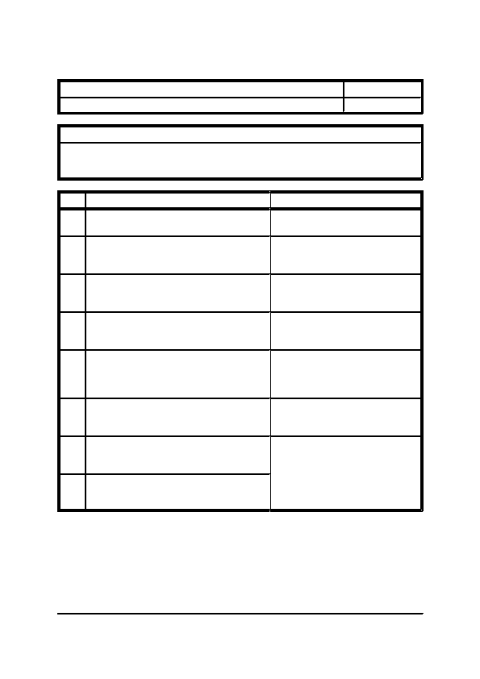
SECTION FIVE

Title: Direct Expansion Air Conditioning Systems

Category: Filling Procedure
Operating Procedures
Item: 5.2.1

Page: 1 of 1
Description: This describes the filling procedure for a direct expansion air conditioning system.

Notes:
1. The following works should only be carried out by a qualified refrigeration engineer using the
correct items of equipment.
Step

1
2
3
4
5
6
7
Action

Carry out a pressure test of the complete
refrigeration pipework system.

Upon completion of a pressure test, release the
pressure very carefully and remove test
equipment.

Fit evacuation equipment to the pipework and
evacuate the lines to remove all air, condensation
etc.

During the evacuation period check over the
equipment to ensure all components are ready to
operate.

Remove evacuation equipment and fit refrigerant
gas canister leads to pipework. Switch on main
electrical supply and begin the filling of the
system.

Upon completion of the filling operation remove
the gas canister leads and check the operation of
all equipment and controls.

Ensure that crankcase heater is functional and
leave system for a minimum of eight hours
before putting into operation.
Notes

Refer to the manufacturers' literature for
pressure limits.

Care should be taken when releasing the
high pressures involved.
Refer to manufacturers' literature for the
quantity of gas to be used.
8
Finally check the function of all controls.
This period allows the heater to reach
its operating temperature and the gas to
settle.

The system is now ready to operate
under the dictates of the controls
system.
General Office Building, Reception Refurbishment
Section 5, Page 4

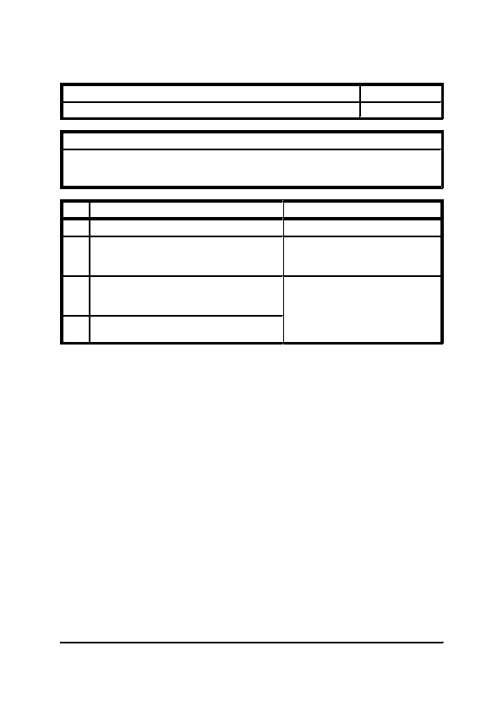
SECTION FIVE

Title: Direct Expansion Air Conditioning System

Category: Draining Procedure
Operating Procedures
Item: 5.3.1

Page: 1 of 1
Description: This describes the procedure for draining a direct expansion air conditioning system.

Notes:
1. The following works should only be carried out by a qualified refrigeration engineer using the
correct items of equipment.
Step

1
Action

Switch off controls operation.

Fit refrigerant gas collection canister leads to the
pipework and draw off the refrigerant.

Upon completion of the degassing process,
disconnect leads, close valves and remove
collection unit.

Switch off local isolators and main electrical
supply.
Notes
2
3
4
All refrigerant must, by law, be
removed for proper recycling or
disposal if contaminated.
This ensures that the crankcase heater is
taken off line.
General Office Building, Reception Refurbishment
Section 5, Page 5


SECTION SIX
MAINTENANCE SCHEDULES


SECTION SIX

INDEX

ITEM
6.1

6.1.1
-

-
Maintenance Schedules
DESCRIPTION
GENERAL

Introduction
6.2

6.2.1
6.2.2
6.2.3
6.2.4
6.2.5
6.2.6
6.2.7
6.2.8
-

-
-
-
-
-
-
-
-
COOLING SYSTEMS

Direct Expansion Air Conditioning Unit
Compressor
Filter (Panel Washable)
Cooling Coil (DX)
Fan
Small Fan
Electric Motor
Insulation
General Office Building, Reception Refurbishment
Section 6, Page 2


SECTION SIX

Title: Introduction

Category: General
Maintenance Schedules
Item: 6.1.1

Page: 1 of 1
Only a regular and organised scheme of maintenance work, planned, to cover all details of the installation,
within given maintenance periods, can ensure continued satisfactory operation with a minimum liability
tointerruptionstosupply duetoequipmentfaults.Aplannedmaintenanceschemeshouldincludeasystem
of logging, wherein records are kept of inspection, maintenance and repair of all items of plant and
equipment.

Careful attention must be given to securing the safety of personnel and equipment while maintenance or
repair work is in progress. A code of safety rules based on a system of "permits to work" is recommended.
Plant rooms should be kept clean and the practice of using plant room space for storage must not be
permitted.Accesstoplantroomsandequipmentmustbelimitedtoauthorisedpersonnelwhoaremembers
of the engineering staff.

Where maintenance work is in progress, a DANGER notice must always be attached to any "live"
apparatus calling attention to the danger of approach. A CAUTION notice must always be attached to
plant or its associated control equipment which may be occasioned by interference. Before any work is
commenced on any item of equipment, the supply and ancillary circuits must be isolated and locked off
if possible.

All safety precautions and general recommended procedures relating to the maintenance of switchgear are
contained in the British Standard CP5405 (1976) and this should be read in conjunction with the
instructions for routine periodic maintenance given in the following pages.
General Office Building, Reception Refurbishment
Section 6, Page 3

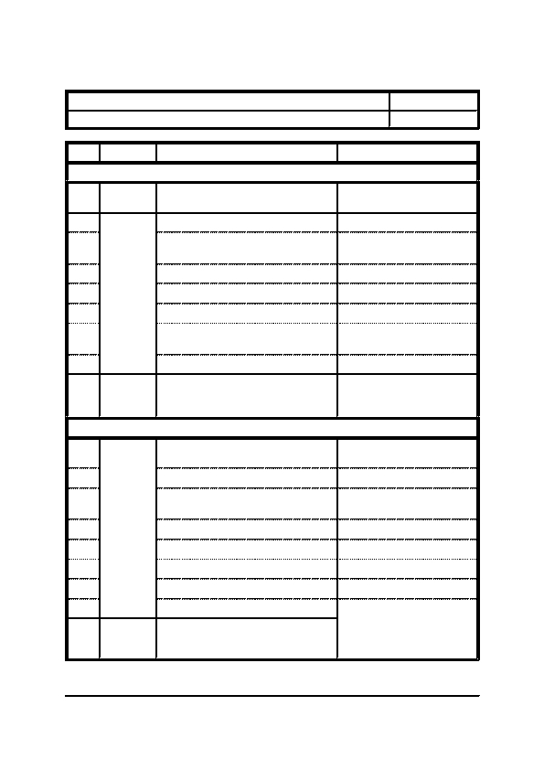
SECTION SIX

Title: Direct Expansion Air Conditioning Unit

Category: Cooling Systems
Item Frequency
Maintenance Schedules
Item: 6.2.1

Page: 1 of 1
1

2

3

4

5

6

7

8
Monthly
3 Monthly
9
Various
1

2

3

4

5

6

7

8
3 Monthly
9
Various
Details

Internal Unit

Remove and clean return air filter.

Clean surfaces of casing.

Brush or vacuum clean evaporator coil
surfaces.

Check for correct operation of controls.

Check fan is free to rotate.

Check for unusual noise or vibration.

Clean out drip tray and ensure condensate
drain is free from obstruction.

Check unit for signs of leakage.

Check and maintain component items -
refer to individual component's
maintenance schedule.

External Unit

Inspect unit for signs of leakage or
corrosion.

Clean condenser coil surfaces.

Check fans are free to rotate and impellers
are secure onto shaft.

Check operation of all controls.

Check refrigerant charge.

Check operation of crankcase heater.

Check crankcase oil level.

Check for unusual noise or vibration.

Check and maintain component items -
refer to individual component's
maintenance schedule.
Notes
Brush clean or wash in warm
soapy water.
Small Fan, Coil, Filter
(Washable Panel)
Clean off any deposits and treat
any bare metal accordingly.
Top up as required.
Top up as required.
Fan, Coil, Compressor
General Office Building, Reception Refurbishment
Section 6, Page 4

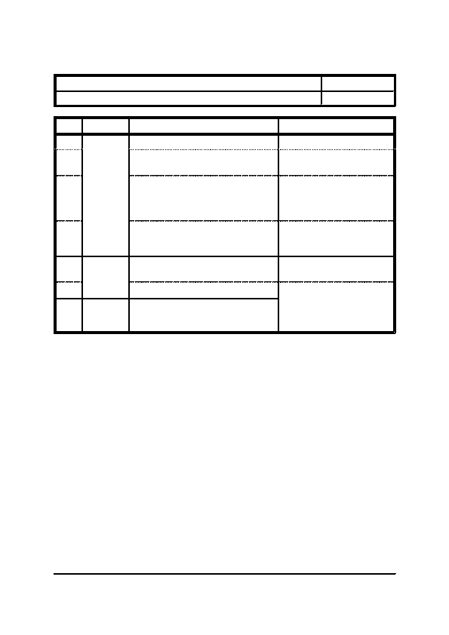
SECTION SIX

Title: Compressor

Category: Cooling Systems
Item

1

2
Frequency
Details

Check compressor for signs of leakage.

Check oil level.
Maintenance Schedules
Item: 6.2.2

Page: 1 of 1
Notes
3
Weekly
Check if oil is contaminated with
refrigerant.
4
Check for unusual noise or vibration.
5

6
Yearly
7
Various
Inspect compressor for signs of corrosion.

Check security of electrical connections.

Check and maintain component items -
refer to individual component's
maintenance schedule.
This can be viewed through the
sight glass. Top up as required.

Excessive foaming will indicate
the presence of refrigerant.
Switch off unit and investigate
cause.

Internal components may be
broken. Overhaul or replace as
necessary.

Remove rust etc and treat any
bare metal accordingly.
Electric Motors.
General Office Building, Reception Refurbishment
Section 6, Page 5

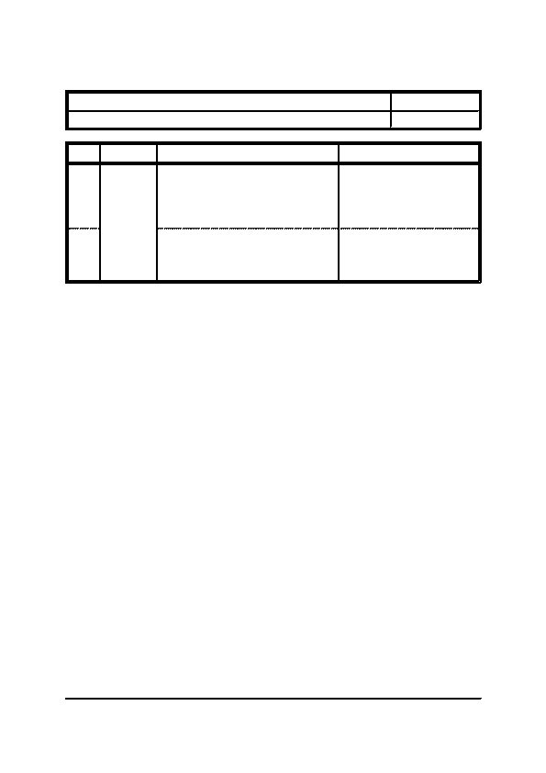
SECTION SIX

Title: Filter (Panel Washable)

Category: Cooling Systems

Item Frequency
Maintenance Schedules
Item: 6.2.3

Page: 1 of 1
1
Monthly
Details

Take manometer reading. If reading
shows the filter cells are at their
maximum pressure drop they should be
washed. After washing check condition of
filter medium, if damaged replace.
2
Wipe any accumulated dirt from the
retaining channels and frames.
Notes

Refer to the Plant Data.

Check cells are replaced in the
correct direction for air flow.

On replacing access doors check
that the integral seals give a
good air seal. If not, replace
seals.
General Office Building, Reception Refurbishment
Section 6, Page 6


SECTION SIX

Title: Cooling Coil (DX)

Category: Cooling Systems
Item

1
Frequency

Monthly
Maintenance Schedules
Item: 6.2.4

Page: 1 of 1
2
3 Monthly
3
Details

Check pipework connections for leaks.

Check coil matrix is clean, unobstructed
and air flow is evenly distributed over
coils.

Check condensate drain pans and
connections are clear. Check drain pipe is
properly attached.
Notes
4
6 Monthly
Clean coil matrix.
5
Yearly
Check air pressure drop across coil.
Use soft brush and mild
detergent solution. If heavily
contaminated with grease use
steam lance. Take care not to
damage or distort fins.

Refer to the Plant Data.
General Office Building, Reception Refurbishment
Section 6, Page 7

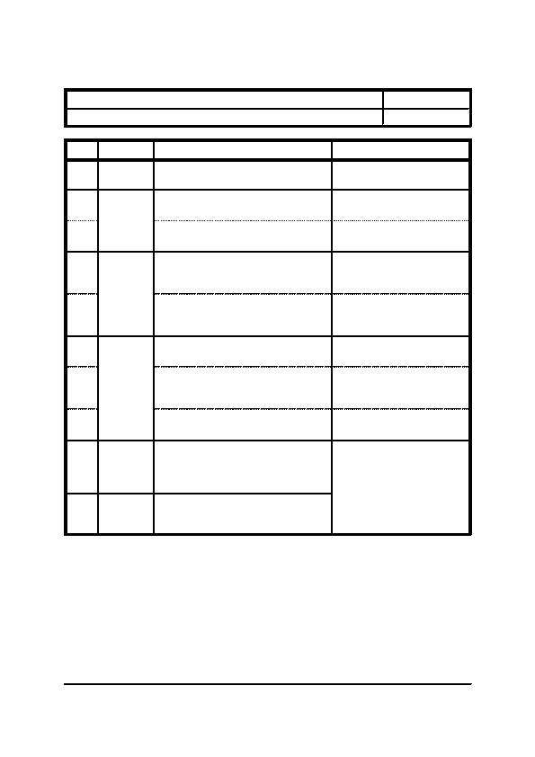
SECTION SIX

Title: Fan

Category: Cooling Systems
Item

1
Frequency

Daily
Maintenance Schedules
Item: 6.2.5

Page: 1 of 1
2
Weekly
3
4
Monthly
5
6
7
6 Monthly
8
9
Yearly
10
Various
Details

Check fan is running smoothly without
excessive noise or vibration.

Check flexible connections are secure,
taut and airtight.

Check that fan guard is clean and
unobstructed.

Check anti-vibration mountings/hangers
are secure, free to move and in good
condition.

Check anti-back draught damper
operation (air tightness and freedom of
movement).

Check impeller and shaft for freedom of
movement and balance.

Check impeller and blades. Check
security of impeller on shaft and inspect
blades for security and damage.

Check performance of fan (shaft speed,
air velocity and pressure).

Clean and check casing internally and
externally, repairing any corrosion or
damage to finish found. Check all bolted
joints are secure.

Check and maintain component items -
refer to individual component's
maintenance schedule.
Notes
Connections must not resist air
flow.
Refer to the certificates and the
Plant Data.
Electric Motor
General Office Building, Reception Refurbishment
Section 6, Page 8

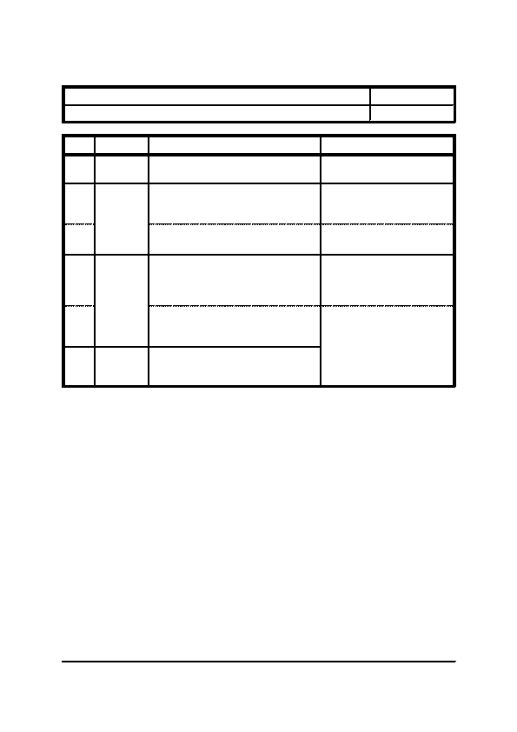
SECTION SIX

Title: Small Fan

Category: Cooling Systems
Item

1
Frequency

3 Monthly
Maintenance Schedules
Item: 6.2.6

Page: 1 of 1
2
6 Monthly
3
4
Yearly
5
6
Various
Details

Clean intake and discharge grilles.

Remove grille and motor/impeller
assembly and clean inner surfaces of
casing.

Vacuum clean motor/impeller assembly.
Refit motor/impeller assembly and grille.

Remove grille and motor/impeller
assembly. Strip down motor/impeller
assembly and clean all items.

Apply a few drops of mineral oil to motor
bearings. Refit motor/impeller assembly
and grille.

Check and maintain component items -
refer to individual component's
maintenance schedule.
Notes

Brush off any debris and wipe
with a damp cloth.
Wash all non-electrical
components in warm soapy
water. Ensure all items are dried
thoroughly.
Electric Motor
General Office Building, Reception Refurbishment
Section 6, Page 9

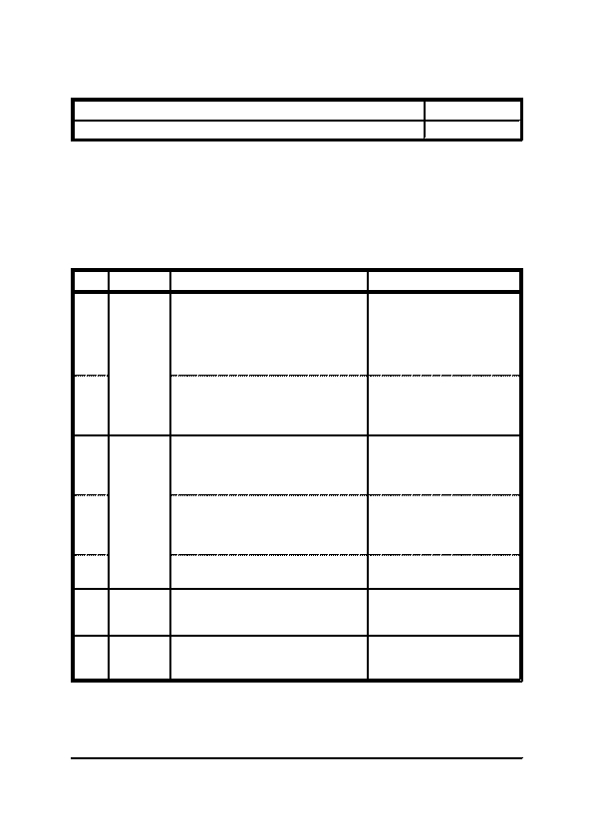
SECTION SIX

Title: Electric Motor

Category: Cooling Systems

Maintenance Notes
(a)
Maintenance Schedules
Item: 6.2.7

Page: 1 of 1
(b)
Always ensure the electrical supply to the motor is positively isolated before carrying out any
work. Do Not rely on a local lockstop button for isolation.

Unless specifically designed for it, electric motors are extremely susceptible to the effect of
extremes of temperature, dust and moisture. Every care must be taken to ensure they operate in
a clean and dry environment.
Frequency
Notes
Item
1
Monthly
2
3
3 Monthly
4
5
6
6 Monthly
7
3 Yearly
Details

Generally check motor to ensure casing
ventilation louvres are unobstructed,
alignment is correct, holding down bolts
and pulley/couplings are secure, and
motor runs without excessive vibration,
temperature or noise.

Totally enclosed motors only - Check that
casing drain holes are unobstructed or if
plugged, remove plugs to drain off any
accumulated condensation.

Check motor terminals are secure, cables
show no signs of overheating, terminal
box is internally dry and clean, and cover
is refitted securely.

Intermittently running motors subjected to
damp conditions - Check that insulation
resistance across winding is at an
acceptable value.

Single phase motors only - Check
centrifugal switch for wear and action.

Check drawn full load current does not
exceed value stated on name plate and as
detailed in the Plant Data.

Dismantle and overhaul motor in
accordance with manufacturers
recommendations.
Positively isolate motor before
carrying out this check.
Note measured current drawn
for future reference and
comparison.

This should be carried out by a
specialist.
General Office Building, Reception Refurbishment
Section 6, Page 10


SECTION SIX

Title: Insulation

Category: Cooling Systems
Item

1

2
Frequency

6 Monthly

Yearly
Details

Inspect outer surfaces for damage. Repair
or replace as necessary.

Check integrity of vapour seals.
Maintenance Schedules
Item: 6.2.8

Page: 1 of 1
Notes
General Office Building, Reception Refurbishment
Section 6, Page 11


SECTION SEVEN
MAINTENANCE INSTRUCTIONS AND LOG BOOKS


SECTION SEVEN

INDEX

ITEM
7.1

7.1.1
7.1.2
7.1.3
-

-
-
-
Maintenance Instructions and Log Books
DESCRIPTION

INTRODUCTION

Formulation of a Planned Maintenance Programme
Energy Usage Log Books
Maintenance Log Books

RISK ASSESSMENTS

Working Alone
Working in Occupied Premises
Working in Confined Spaces
Working at Heights
Use of Ladders
Use of Trestles
Use of Hand Tools

C.O.S.H.H. INSTRUCTIONS

Introduction
Refrigerant Gas
Foam Insulation

SAMPLE LOG BOOKS

General Maintenance Log Book
7.2

7.2.1
7.2.2
7.2.3
7.2.4
7.2.5
7.2.6
7.2.7
-

-
-
-
-
-
-
-
7.3

7.3.1
7.3.2
7.3.3
-

-
-
-
7.4

7.4.1
-

-
General Office Building, Reception Refurbishment
Section 7, Page 2


SECTION SEVEN

Title: Formulation of a Planned Maintenance Programme

Category: Introduction
Maintenance Instructions and Log Books
Item: 7.1.1

Page: 1 of 1
This Operating and Maintenance Manual is designed for use by "In-House" maintenance personnel and
it is recommended that a Planned Maintenance Programme is formulated to ensure the safe and efficient
operation of the plant and systems installed.

It is also recommended that a log book of any preventative maintenance tasks, faults and subsequent
corrective maintenance tasks carried out, is kept. This will provide any new maintenance personnel with
a history of the systems installed and highlight key areas that may require attention.

Thefollowingschedulesincorporatetwotypesofmaintenance,firstly thehighfrequency items aremainly
checks to ensure that the plant and systems are operating correctly. Secondly, the lower frequency items
mainly consist of preventative maintenance tasks to ensure that the plant and system continue to operate
in a safe and efficient manner.

In the formulation of a Planned Maintenance Programme, it is important to identify those items which are
simply checksand thosewhich arepreventativemaintenancetasks.Althougheachindividual maintenance
schedule needs to be read and understood before this can be determined, a general rule (which will not
apply in all circumstances) can be applied. All items with a frequency greater than one month are checks
and any items with a frequency less than one month are maintenance tasks. Items with a frequency of one
month will vary from one item of equipment to the next and the general rule cannot be applied here.

Although the frequency of the preventative maintenance task is specified, the careful scheduling of the
maintenance needs to be made to minimise any inconvenience caused to the building occupier.
General Office Building, Reception Refurbishment
Section 7, Page 3


SECTION SEVEN

Title: Energy Usage Log Books

Category: Introduction
Maintenance Instructions and Log Books
Item: 7.1.2

Page: 1 of 1
The effective implementation of a planned preventative maintenance regime, as outlined within previous
sections of this document, would be incomplete without the monitoring of energy usage as outlined within
the Building Regulations, Part L2, Conservation of Fuel and Power (2006 Edition).

As detailed within the above regulation, suitable metering for this building will have been included within
thesystemsatthedesignconceptionstage,togetherwithestimatednormalenergy usagecalculations.This
information, updated to incorporate changes following system alteration, should be used as a baseline
comparison to the continual log of energy usage. Any discrepancies found, either higher or lower than the
estimated energy usage, should be investigated and if necessary remedial action taken. For example,
higher than normal usage could indicate, leaks, insulation damage or faulty equipment.

NOTE: It must be remembered that such comparisons of baseline figures to actual readings have little
meaning with regard to day-to-day usage. Only average figures over years/months should be used
to highlight potential problems and changes to system operation.
General Office Building, Reception Refurbishment
Section 7, Page 4


SECTION SEVEN

Title: Maintenance Log Books

Category: Introduction
Maintenance Instructions and Log Books
Item: 7.1.3

Page: 1 of 1
In addition to the energy usage logs, a general log of preventative and remedial maintenance, should also
be kept to assist with the diagnosis of potential problems and to provide a history of maintenance for
future personnel. The exact arrangement of this maintenance log will be dependant on the preferences and
regime implemented by the maintenance personnel, however, a logical approach to the record keeping is
essential, particularly to cater for staff changes.

There are three main options with regards to the structure of record keeping as follows:-
1)
2)
3)
Chronological
System by System
Equipment Basis
All maintenance actions are recorded in chronological order.
Separate log books are kept for each system.
Separate log books are kept for each item of equipment.
The advantages/disadvantages of each approach are summarised in the following table:-
Type

Chronological
Advantages

Extremely simple and compact method
of keeping records.
System
Equipment
Historical comparison and
identification of potential problems
easily achieved.

Greatest flexibility regarding historical
comparison.
Disadvantages

Locating historical information for any
given item of equipment could prove
difficult.

Slightly more complex and bulky
system of keeping records than the
simple chronological approach.

No more complex than the system
approach, however, "documentation
overload" could occur due to the sheer
amount of paperwork being kept. Cross
references between one item of
equipment and another on the same
system could prove difficult to
maintain.
General Office Building, Reception Refurbishment
Section 7, Page 5

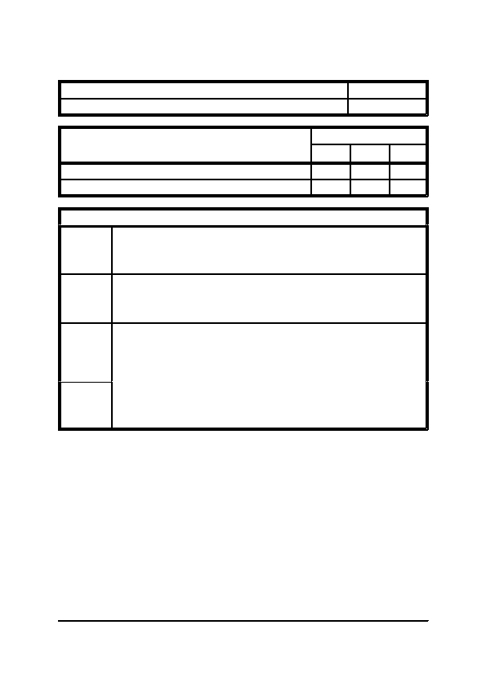
SECTION SEVEN

Title: Working Alone

Category: Risk Assessments
Maintenance Instructions and Log Books
Item: 7.2.1

Page: 1 of 1
Assessment of Risk
Low
Medium

3

3
High
Description of Risk
Falling from a height

Electric shock
Planning
Physical
Managerial
Training
Actions to be Taken to Minimise the Risk

Correct planning should include an assessment of the work, so that the likelihood of
injury and the possible consequences to the lone worker are considered. Where there
are hazardous substances, live electrical work, the need to work at height or near
water, lone working should be avoided.

Lone worker alarms or other means of communication should be provided. First aid
facilities to treat minor injuries should be available during work periods and those
working alone should be advised of their location. Suitable means of access should
be provided which can be handled safely by one person.

Peripatetic workers should be supervised on a regular basis and management should
ensure that their whereabouts are known at all times. Only experienced and trained
operatives, with no adverse medical history, should be considered for working alone.
The permitted limits of work and the limits on the initiative of the individual should
be clearly specified before work is authorised.

Levels of training and experience for lone workers should include a full
understanding of the work involved, together with a thorough knowledge of the
hazards and emergency procedures. Workers should also clearly understand the
limits of the work which have been authorised and the limits on their own initiative.
General Office Building, Reception Refurbishment
Section 7, Page 6

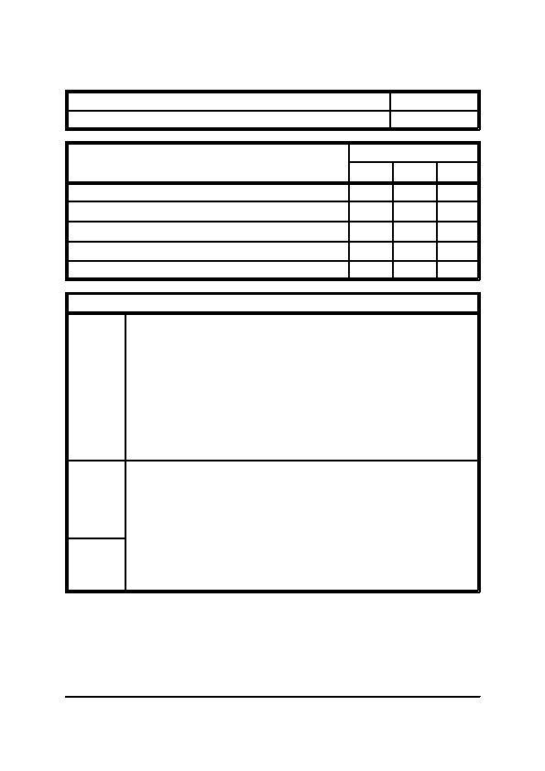
SECTION SEVEN

Title: Working in Occupied Premises

Category: Risk Assessments
Maintenance Instructions and Log Books
Item: 7.2.2

Page: 1 of 1
Assessment of Risk
Low
Medium

3

3

3

3
High
Description of Risk

Electric shock/burns

Fire

Falling from heights

Injuries to third parties - falls

Injuries to third parties - falling objects
3
Planning
Managerial
Training
Actions to be Taken to Minimise the Risk

Planning should include the exchange of information with owner/occupier to ensure
full reciprocal knowledge of existing hazards, demarcation of areas of responsibility
and work hazards. Access equipment should be provided to ensure the maximum
safety of workers and occupants. Details of existing services should be obtained
before the commencement of works and COSHH and noise assessments should be
available for materials and tools to be used. Physical barriers and notices should be
installed to isolate work from occupants and members of the public. Fire exit routes
should be kept free from obstruction and alternate routes should be clearly signed.
Hot work should be controlled and extinguishers on hand. Where work at height
needs to be carried out, debris netting, fans or other suitable measures to protect the
public should be installed. Flammable and hazardous materials should be correctly
controlled and stored.

Supervisors should monitor all works, carrying out initial checks to ensure that safe
systems of work are in place before commencement and that areas are left safe at the
end of each work period. Regular liaison should take place with occupants to co-
ordinate work and eliminate hazards to them. Use of personal protective equipment
and ventilation equipment should be monitored to ensure compliance with COSHH
assessments.

Induction training should include any hazards and necessary precautions required for
the workplace. Operative training should include safe systems of work and
precautions designed to prevent injury to third parties. Supervisory management
should be trained in site safety supervision.
General Office Building, Reception Refurbishment
Section 7, Page 7

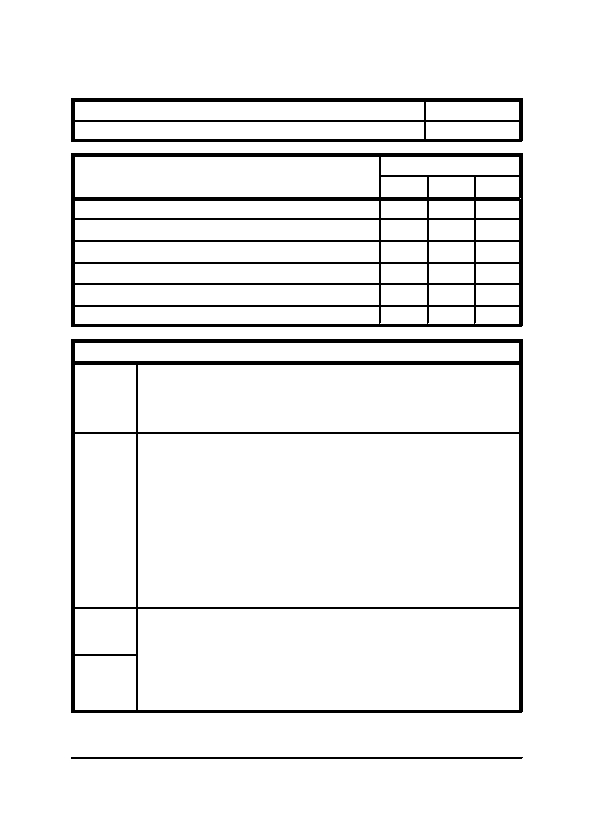
SECTION SEVEN

Title: Working in Confined Spaces

Category: Risk Assessments
Maintenance Instructions and Log Books
Item: 7.2.3

Page: 1 of 1
Assessment of Risk
Low Medium
High

3

3

3

3
Description of Risk

Poisoning from toxic gases

Asphyxiation - lack of oxygen

Explosion

Fire

Excessive heat

Drowning
3
3
Planning
Physical
Managerial
Training
Actions to be Taken to Minimise the Risk

Planning should eliminate the need for entry or use of hazardous materials by the
selection of alternative methods of work or materials. An assessment of the
ventilation available and possible local exhaust ventilation requirements should be
made, together with the potential presence of hazardous gases/atmosphere, process
by products and the need to improve hygiene/welfare facility.

A documented entry system should be applied, preferably a Permit to Work System
and adequate ventilation should be present. Detection equipment should be present
before entry to check on levels of oxygen and presence of toxic or explosive
substances. The area should be tested before entry and continually whilst any person
is in the confined space. Breathing apparatus or airlines should be provided if local
ventilation is not possible. Where no breathing apparatus is assessed as being
required, emergency breathing apparatus and rescue harnesses should be provided.
Rescue equipment, including lifting equipment, resuscitation facilities, safety lines
and harnesses should be provided and a communication system with those in the
confined space should be established. Air should not be sweetened with pure oxygen
and precautions for the safe use of any plant or heavier-than-air gases in the confined
space should be established before entry. Necessary personal protective equipment
and hygiene facilities should be provided for those entering sewers.

The management's role should be to decide on the nature of the confined space and
put a safe system into operation, including checking the above. Flood potential and
isolations should be checked.

Full training should be provided for all persons entering and managing confined
spaces. A surface rescue party should be trained in first aid procedures and the
operation of testing equipment. All operatives and supervisory staff should be
certified as trained to the same standard.
General Office Building, Reception Refurbishment
Section 7, Page 8

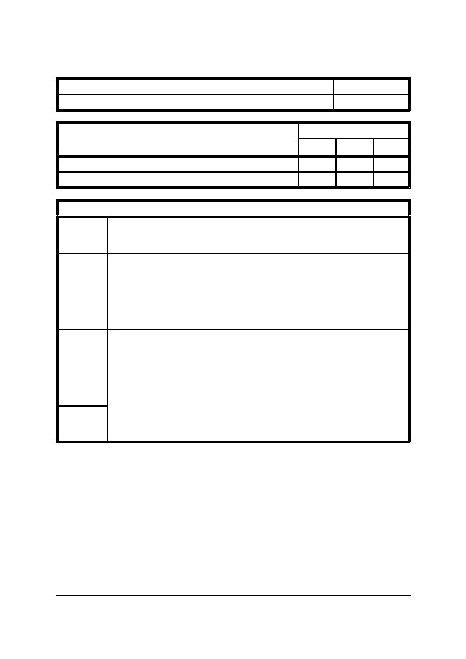
SECTION SEVEN

Title: Working at Heights

Category: Risk Assessments
Maintenance Instructions and Log Books
Item: 7.2.4

Page: 1 of 1
Assessment of Risk
Low
Medium

3
High
Description of Risk
Falls of persons

Falls of materials
3
Planning
Physical
Managerial
Training
Actions to be Taken to Minimise the Risk

Work should be planned to ensure that a safe means of access is provided. Reference
should also be made to the use of access equipment. All equipment should be
provided and maintained to the required legal standards..

Suitable signs and barriers should be positioned directly below the works to warn of
overhead operations. Edge protection should be erected at places of work, where
falls of more than 2 metres could occur. Where edge protection is removed for
access, or is not reasonably practicable, personal suspension equipment should be
used by operatives working at or near the edge. Where there is likely to be falling
debris, chutes or full enclosures should be used to protect third parties. All operatives
working below overhead operations should wear safety helmets.

All equipment used should be checked to ensure it is in good order, to correct
specification and in date for inspection. Work should be monitored to ensure that
additional precautions and equipment is taken into use if edge protection is removed.
Other relevant British Standards include: BS 7883:1997 - Anchors for Safety
Harnesses, BS 8213 Part 1:1991 - Code of Practice for Cleaning of Windows and
Doors, BS EN 355, 358, 361-365 - Personal Protective Equipment Against Falls
from a Height.

Training and instruction should be provided to all operatives and supervisory staff
involved in the use of suspension equipment, such as lines and harnesses and how to
inspect and assess personal protective equipment of this type before use.
General Office Building, Reception Refurbishment
Section 7, Page 9

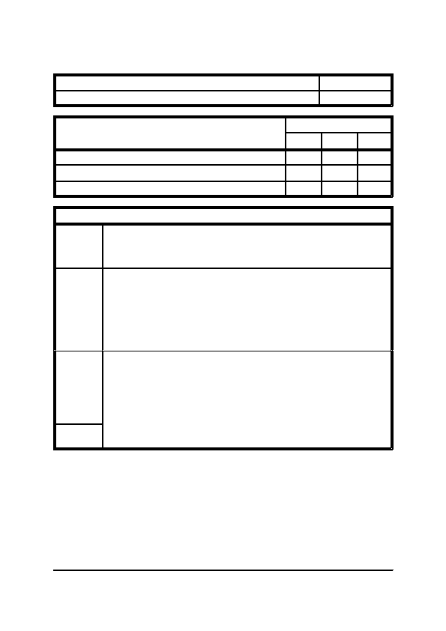
SECTION SEVEN

Title: Use of Ladders

Category: Risk Assessments
Maintenance Instructions and Log Books
Item: 7.2.5

Page: 1 of 1
Assessment of Risk
Low
Medium

3

3
High
Description of Risk

Falls of persons from ladders

Ladder slipping

Objects dropping by ladder user
3
Planning
Physical
Managerial
Training
Actions to be Taken to Minimise the Risk

Ladders should be checked to ensure correct length, type and condition before use
and should be subject to a planned maintenance programme. Ladder work should be
restricted to that which can be carried out using one hand only and will only take
twenty minutes to complete.

The ground base for the ladder should be firm and level. The ladder should be of
sufficient length to extend a sufficient height above the step-off point when used as
access to a scaffold. The correct angle of rest for a ladder is 75 degrees, or a base to
height ratio of 1:4. Ladders should be secured against slipping, by tying at the top or
the bottom. Ladders should only be footed as a sole precaution against movement if
less than 3 metres high. Overreaching from ladders should be avoided. When using
stepladders the hips should be kept below the top platform and between the stiles to
ensure stability.

Supervisors should check ladders before use to ensure they are sound. Use made of
ladders should be monitored regularly, to ensure that operatives are not overreaching
or using two hands to work. Damaged ladders should be broken up or removed from
the workplace immediately. Painted ladders should not be accepted for use.
Managers should check method statements supplied by sub-contractors and others,
e.g. window cleaners, to ensure that ladders will be used correctly and that safe
access will be available.

All operatives should be trained in the safe use of ladders and the hazards which
must be avoided. This should be done at induction.
General Office Building, Reception Refurbishment
Section 7, Page 10

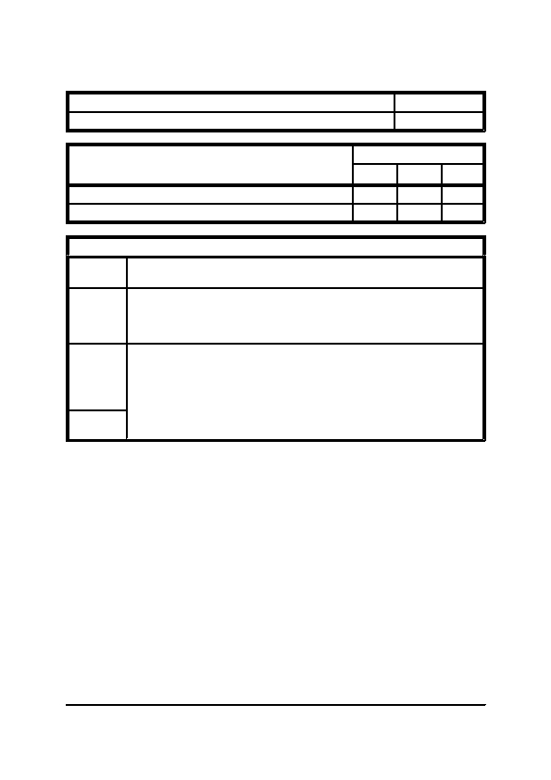
SECTION SEVEN

Title: Use of Trestles

Category: Risk Assessments
Maintenance Instructions and Log Books
Item: 7.2.6

Page: 1 of 1
Assessment of Risk
Low
Medium

3

3
High
Description of Risk

Falls of persons and materials from working platform

Collapse of trestles
Planning
Physical
Managerial
Training
Actions to be Taken to Minimise the Risk

Lightweight staging or mobile access scaffold should be used in preference to
trestles. Trestles should only be planned for light work of relatively short duration.

Lightweight staging should be used in preference to boards and be positioned so that
at least one-third of the height of the trestle is above the platform. Staging/platform
width should be at least 600mm. Toe-boards and guardrails are required to platforms
above 2 metres in height.

All equipment used should be checked to ensure it is in good order before use, to
ensure no loose or damaged cross bearers, the hinges are in good order and that there
are no defective stiles (loose or missing bolts or screws). Management should
supervise the use of trestles to ensure that operatives moving and erecting trestles are
properly trained and instructed and that those using trestles do not overreach.

Training and instruction should be provided to all operatives and supervisory staff
involved in the use of trestles as above.
General Office Building, Reception Refurbishment
Section 7, Page 11


SECTION SEVEN

Title: Use of Hand Tools

Category: Risk Assessments
Maintenance Instructions and Log Books
Item: 7.2.7

Page: 1 of 1
Assessment of Risk
Low
Medium

3
High
Description of Risk

Eye Injury

Injury to hands, feet and body
3
Planning
Physical
Managerial
Training
Actions to be Taken to Minimise the Risk

Tools provided by the employer should be assessed to ensure they are fit for the
environment in which they are to be used and in good working condition. Tools are
required to be suitable for the purpose for which they will be used.

Eye protection should be provided and used whenever work is carried out using cold
chisels, drills, grinders or other tools where there is a risk of flying particles or pieces
of the tool breaking off. Open-bladed knives, screwdrivers and other sharp tools
should be carried and used so as not to cause injury to the user or others. Non-ferrous
(spark-free) tools should be used in flammable atmospheres. Insulated tools should
be used where there is a possibility of live electrical work.

Management should monitor hand tools which can deteriorate with use, to ensure
they are sharpened or replaced as necessary and that the correct tools are being used
properly. Specific checks should be made as follows:
Chisels for mushroom heads
Hammer and file handles for deterioration and exposed tangs
Open-ended spanners for splayed jaws.

Operative should be instructed in the correct method of use and in maintenance
requirements at induction if not part of craft training.
General Office Building, Reception Refurbishment
Section 7, Page 12


SECTION SEVEN

Title: Introduction

Category: C.O.S.H.H. Instructions
Maintenance Instructions and Log Books
Item: 7.3.1

Page: 1 of 1
The Control of Substances Hazardous to Health (C.O.S.H.H.) 2002 regulation place a duty on employers
to ensure that their employees are not exposed tosubstanceshazardousto health, ie. to solids/liquids/gases
that are toxic/harmful/corrosive/irritant. Safety guidelines, for example, for concentrations of substances
in air, are separately prescribed by the appropriate authorities.

The following pages within this sub-section give a general indication of the potential hazards presented
and procedures for the safe storage, handling and disposal of the various chemicals and materials likely
to be encountered during the operation and maintenance of the system.

It is essential however that the specific C.O.S.H.H. data sheet (also known in some instances as a
Chemical Safety Data Sheet (C.S.D.S) or a Material Safety Data Sheet or M.S.D.S.) for any chemicals or
materials used are acquired, read, understood and followed by all personnel. The purpose therefore of this
sub-section is for planning information to ensure that all necessary procedures are in place prior to the
purchase of the chemicals or materials.
General Office Building, Reception Refurbishment
Section 7, Page 13

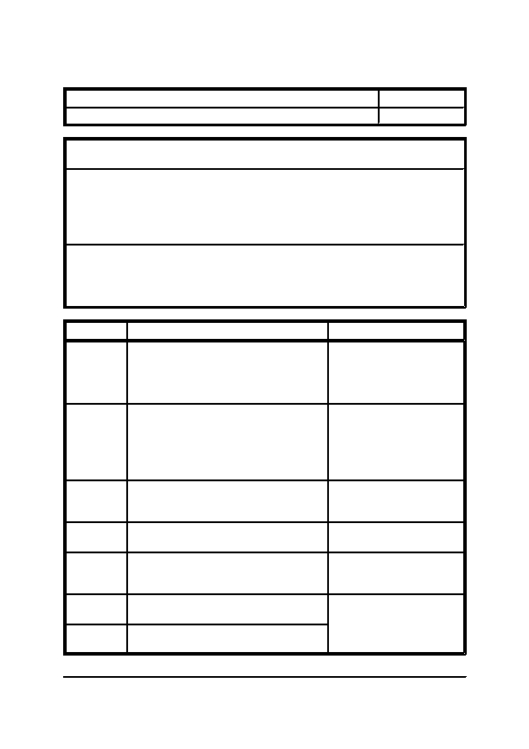
SECTION SEVEN

Title: Refrigerant Gas

Category: C.O.S.H.H. Instructions
Maintenance Instructions and Log Books
Item: 7.3.2

Page: 1 of 1
Description: This describes the general procedures for the safe storage, handling and disposal of
refrigerant gasses, together with how to treat contamination.

Health Hazard Data:
Skin Contact:
Eye Contact:
Inhalation:
Liquid splashes or sprays may cause freeze burns.
Liquid splashes or sprays may cause freeze burns.
Low toxicity with normal concentrations, high exposures can cause abnormal heart
rhythm and prove suddenly fatal. Very high exposures may cause anaesthetic
effects and asphyxiation.
Notes:
1. It is essential that the specific C.O.S.H.H. data sheet for the gas to be used is acquired, read,
understood and followed by all personnel prior to its use.
2. If there is any doubt as to the subjects condition then medical attention should be sought
immediately.
Procedure
Storage
Actions

The canisters should be stored in a cool (below
45 oC), dry, well ventilated space away from
sunlight and sources of heat. The canisters
should be stored away from ventilation intakes
of any system and away from open drains.
Notes
Handling
Use specialised refrigerant charging equipment
and suitable respiratory equipment in
unventilated spaces. Charging should be made
using the liquid phase and not the vapour phase.
Refrigerant transfers can cause a
build up of static electricity, all
apparatus should be earthed. In
the event of leakage it should be
noted that refrigerant gasses will
accumulate at floor level.
Disposal
Skin Contact
Unwanted refrigerant gas should be collected
for recycling if at all possible, or else destroyed
by a suitably licensed agent.

Thaw affected areas with warm water, remove
contaminated clothing.

Remove any contact lenses and wash eyes with
copious amounts of fresh water.

Relocate the subject to the fresh air and perform
artificial respiration if necessary.

Do not induce vomiting. If conscious drink
250ml of water and keep warm.
Eye Contact
Inhalation
Ingestion
Clothing may be frozen to skin,
thaw first.

Behind the eye lids should also
be washed for 15 minutes. Seek
medical attention immediately.

Seek medical attention
immediately.

Seek medical attention
immediately.
General Office Building, Reception Refurbishment
Section 7, Page 14

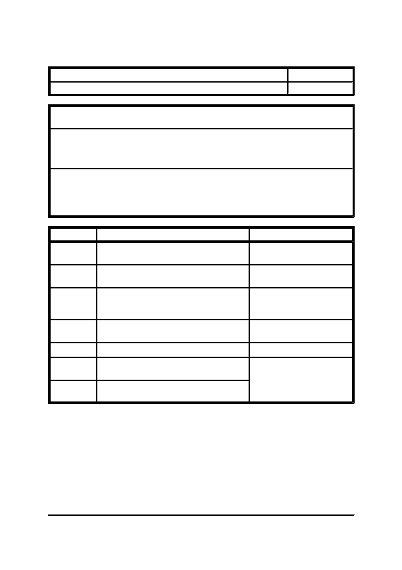
SECTION SEVEN

Title: Foam Insulation

Category: C.O.S.H.H. Instructions
Maintenance Instructions and Log Books
Item: 7.3.3

Page: 1 of 1
Description: This describes the general procedures for the safe storage, handling and disposal of
foam based insulating materials, together with how to treat contamination.

Health Hazard Data:
Skin Contact:
Eye Contact:
Inhalation:

Notes:
No observed hazards.
In particulate form irritation may occur.
Potential irreversible effects if burnt.
1. It is essential that the specific C.O.S.H.H. data sheet for the material to be used is acquired, read,
understood and followed by all personnel prior to its use.
2. If there is any doubt as to the subjects condition then medical attention should be sought
immediately.
Procedure

Storage
Handling
Disposal
Skin Contact

Eye Contact

Inhalation
Actions

There are no special storage requirements for
this product.

Gloves and goggles should be used when
installing.

General good housekeeping measures should
prove sufficient. Controlled combustion and
burial are required for large quantities.

Any contact with burning material should be
doused with cold water, but not removed.

Treat as any particulate such as dust or grit.

Not applicable unless burnt.
Notes
Seek medical attention
immediately.
Ingestion
Do not induce vomiting.
Seek medical attention
immediately.

Seek medical attention
immediately.
General Office Building, Reception Refurbishment
Section 7, Page 15

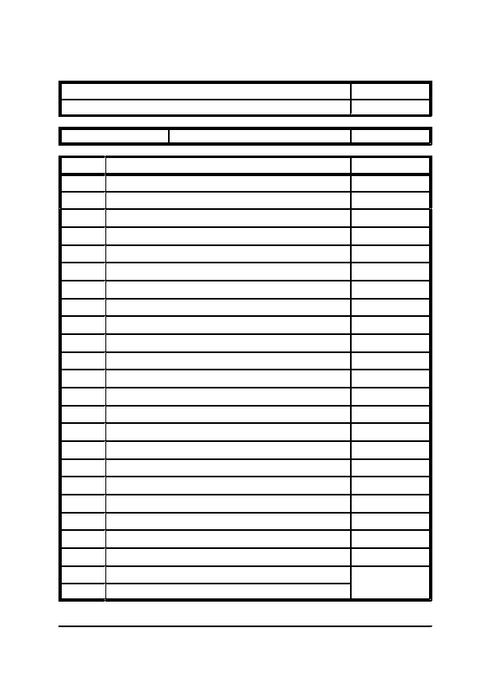
SECTION SEVEN

Title: General Maintenance Log Book

Category: Sample Log Books

System Description:
Date
Description of Action Taken
Maintenance Instructions and Log Books
Item: 7.4.1

Page: 1 of 1
Page Number:
By (Sign & Print)
General Office Building, Reception Refurbishment
Section 7, Page 16


SECTION EIGHT
FAULT TRACING CHARTS


SECTION EIGHT

INDEX

ITEM
8.1

8.1.1
8.1.2
-

-
-
Fault Tracing Charts
DESCRIPTION

GENERAL

Introduction
Preliminary Investigation

MISCELLANEOUS EQUIPMENT

Direct Expansion Air Conditioning Unit
Compressor
Fan
Small Fan
Coil (DX)
Motor
8.2

8.2.1
8.2.2
8.2.3
8.2.4
8.2.5
8.2.6
-

-
-
-
-
-
-
General Office Building, Reception Refurbishment
Section 8, Page 2


SECTION EIGHT

Title: Introduction

Category: General
Fault Tracing Charts
Item: 8.1.1

Page: 1 of 1
Fault tracing of the electrical installation or appliances that are connected to the installation should only
be carried out by suitably trained competent personnel.

Whenever possible all fault tracing should be carried out on circuits, appliances or components after they
have been suitably isolated from the main supply.

When it is not possible to carry out fault tracing on a "dead" installation, then the fault tracing must be
carried out by a minimum of two people.

Prior to carrying out any fault tracing it is essential that the personnel involved read the health and safety
section of this manual and familiarise themselves with the operation and maintenance sections.
General Office Building, Reception Refurbishment
Section 8, Page 3


SECTION EIGHT

Title: Preliminary Investigation

Category: General
Fault Tracing Charts
Item: 8.1.2

Page: 1 of 1
Following a reported failure of an appliance, the likely cause can be quickly established by asking the
relevant question of those in the vicinity of the failure.
a)

b)

c)

d)

e)
f)

g)
h)
Was the appliance or component operating when it failed, or did it fail to start?

Do other items of equipment on the same circuit still operate?

Has the correct operating procedure been carried out?

When was the last time the component/appliance was used?

Had there been any signs of deterioration in the performance or any increase in noise levels from
the appliance/component?

Has there been any maintenance work carried out prior to the failure?

Has any work been carried out in the vicinity of the failure, or along the route of the failed circuit
prior to the failure?

Has anyone else investigated the failure prior to those now required to do so and if so what did
they do and what did they find out?
General Office Building, Reception Refurbishment
Section 8, Page 4

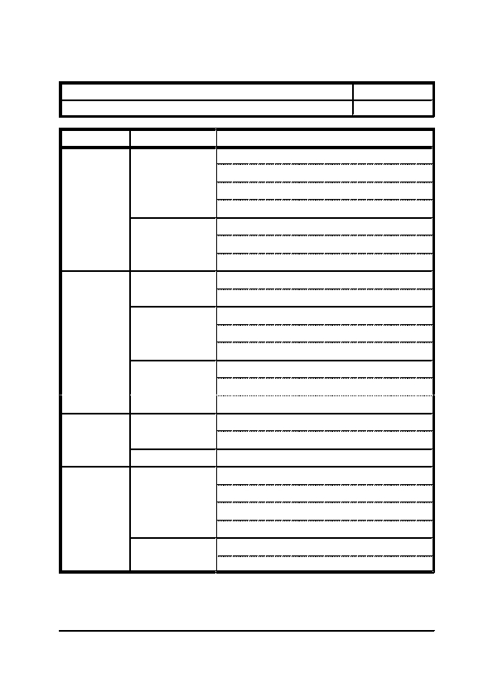
SECTION EIGHT

Title: Direct Expansion Air Conditioning Unit - Indoor Unit

Category: Miscellaneous Equipment

Symptom Possible Cause
Fault Tracing Charts
Item: 8.2.1

Page: 1 of 4
Electrical
Fan Not
Working
Drive Mechanism
Electrical
Resistance
Duty Low
Refrigerant
Duty High
Electrical

Resistance
Drive Mechanism
Excessive
Vibration
General
Checks

Check that electrical supply is available at fan.

Check local isolator is switched on.

Check for loose electrical connections.

Check controller is calling for fan to run.

Check motor is working.

Check if fan blowers are aligned.

Check inlet and outlet of fan for obstruction.

Check for correct supply voltage.

Check for correct control set points.

Check condition of air filter.

Check condition of evaporator fins for fouling.

Check for correct system balance.

Check for leaks in systems.

Check for excessive high head pressure.

Check for blocked expansion valve orifice.

Check for correct supply voltage.

Check for correct controls set points.

Check correct system balance.

Check for correct balance of fan impeller.

Check condition of bearings.

Check for drive shaft distortion.

Check motor balance.

Check security of casing.

Check security of pipework.
General Office Building, Reception Refurbishment
Section 8, Page 5

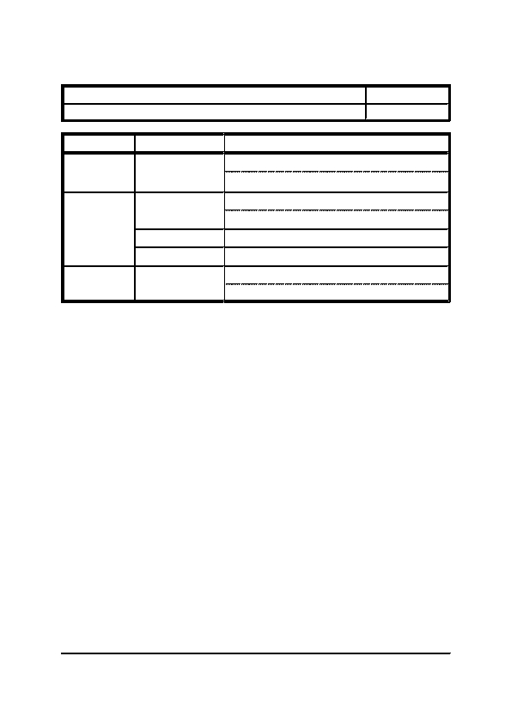
SECTION EIGHT

Title: Direct Expansion Air Conditioning Unit - Indoor Unit

Category: Miscellaneous Equipment
Symptom

Excessive
Vibration
(Continued)
Possible Cause
Fault Tracing Charts
Item: 8.2.1

Page: 2 of 4
Mountings
Excessive Noise
Water Leakage
Drive Mechanism

Damage

Vibration

Blocked Drain
Checks

Check security of mounting bolts.

Check condition of anti-vibration mounts.

Check condition of bearings.

Check condition of motor.

Check impeller for impingement on casing.

Refer to previous symptom.

Check condensate tray for obstruction.

Check condensate drain for obstruction.
General Office Building, Reception Refurbishment
Section 8, Page 6

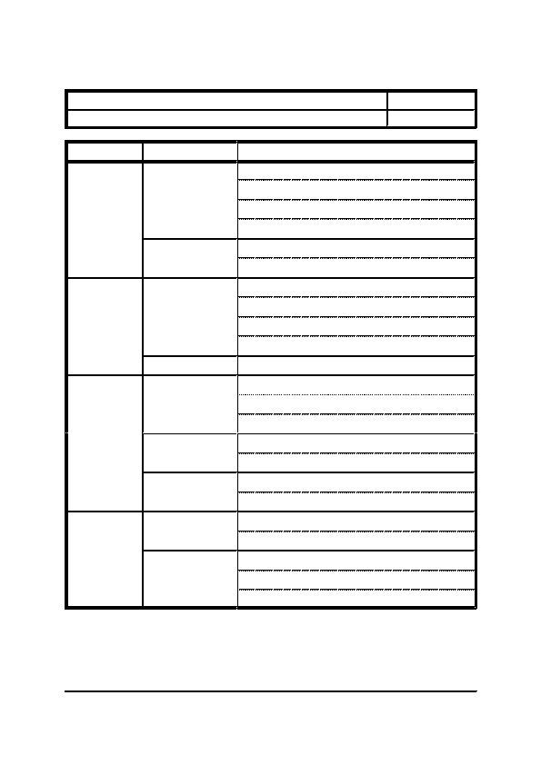
SECTION EIGHT

Title: Direct Expansion Air Conditioning Unit - Outdoor Unit

Category: Miscellaneous Equipment

Symptom Possible Cause
Fault Tracing Charts
Item: 8.2.1

Page: 3 of 4
Electrical
Fan Not
Operating
Drive Mechanism
Compressor Not
Operating
Electrical
Mechanical
Drive Mechanism
Excessive
Vibration
General
Mountings
Drive Mechanism
(Fan)
Excessive Noise
Compressor Fault
Checks

Check that electrical supply is available at fan.

Check that local isolator is switched on.

Check for loose electrical connections.

Check controller is calling for fan to run.

Check motor is working.

Check fan is free to rotate.

Check that electrical supply is available at compressor.

Check isolator is on.

Check for loose electrical connections.

Check for compressor motor failure.

Check for compressor seizure.

Check for correct balance of fan impeller.

Check condition of bearings.

Check motor balance.

Check security of casing.

Check security of pipework.

Check security of mounting bolts.

Check security of anti-vibration mounts.

Check condition of bearings.

Check condition of motor.

Check oil level.

Check for broken or damaged compressor valve reeds.

Check for worn or scored bearings.
General Office Building, Reception Refurbishment
Section 8, Page 7

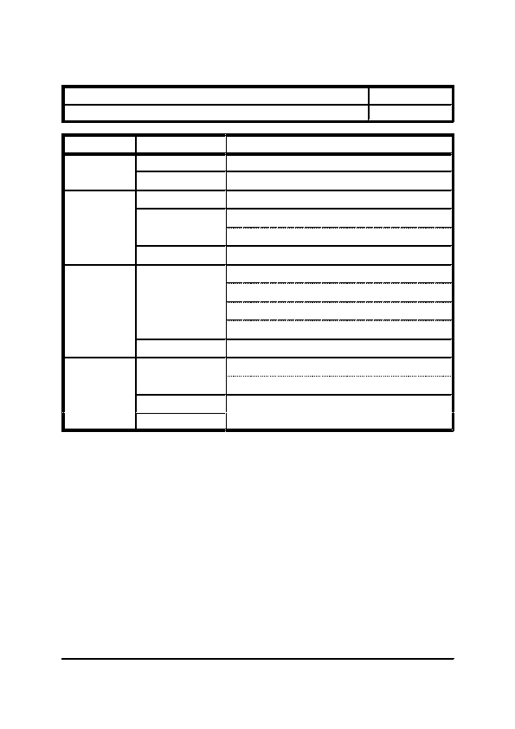
SECTION EIGHT

Title: Direct Expansion Air Conditioning Unit - Outdoor Unit

Category: Miscellaneous Equipment
Symptom

Excessive Noise
Continued
Possible Cause

Damage

Vibration

Fan Not Working

Refrigerant

General
Fault Tracing Charts
Item: 8.2.1

Page: 4 of 4
Excessive Head
Pressure
Low Suction
Pressure
Refrigerant
General

Refrigerant

Controls

Compressor
Excessive
Suction
Pressure
Checks

Check fan impeller for impingement on casing.

Refer to previous symptom.

Refer to previous symptom.

Check for overcharge of gas.

Check for contaminants in refrigerant lines.

Check condenser coil for obstruction.

Check piping for leaks.

Check refrigerant charge.

Check for obstruction in flow control device.

Check for clogged filter drier.

Check for obstruction or icing on coil.

Check refrigerant charge.

Check flow through flow control device.

Check setting of head pressure controller.

Check for damage to compressor reeds.
General Office Building, Reception Refurbishment
Section 8, Page 8

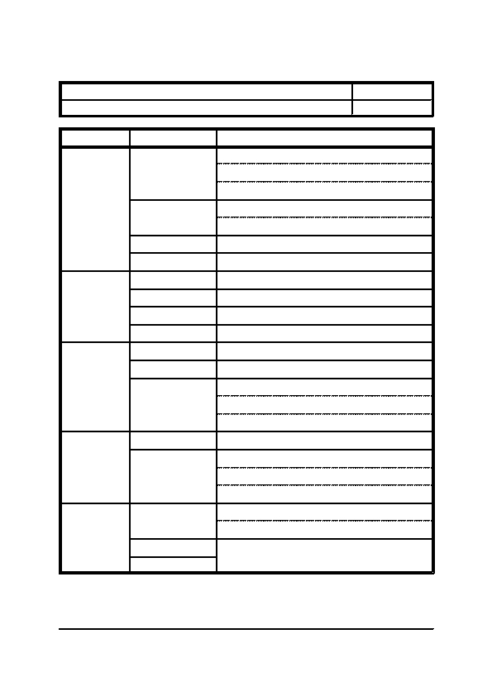
SECTION EIGHT

Title: Compressor

Category: Miscellaneous Equipment

Symptom Possible Cause
Fault Tracing Charts
Item: 8.2.2

Page: 1 of 1
Electrical
Will Not
Operate
Stops
Controls

Motor

Mechanical

Electrical

Controls

Pipeline

Compressor

Controls

Motor
Short Cycles
Pipeline
Controls
Runs
Continuously
Pipeline
Noisy
Compressor

Pipeline

Controls
Checks

Check if electrical supply is available at unit.

Check if local isolator is switched on.

Check for correct electrical supply voltage.

Check controls are calling for compressor to run.

Check for correct operation of all control components.

Check for a seized or burnt out motor.

Check for locked or damaged components.

Check for a loss of electrical supply.

Check for safety cut-out in controls.

Check refrigerant charge.

Check oil level.

Check for correct operation of controls.

Motor faulty.

Check condition of drier core.

Check condition of solenoid valves.

Check refrigerant charge.

Check for correct operation of controls.

Check refrigerant charge.

Check condition of drier core.

Check condition of solenoid valve.

Check oil level.

Check for broken internal components.

Check for correct operation of solenoid valves.

Check for correct operation of control items.
General Office Building, Reception Refurbishment
Section 8, Page 9

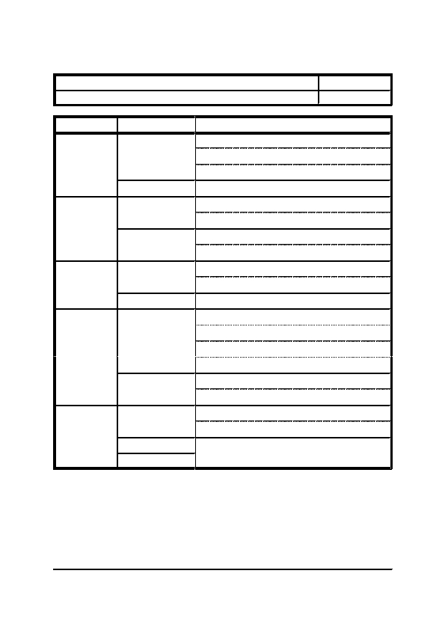
SECTION EIGHT

Title: Fan

Category: Miscellaneous Equipment

Symptom Possible Cause
Fault Tracing Charts
Item: 8.2.3

Page: 1 of 1
Electrical Supply
Not Running
Drive Mechanism

Electrical Supply
Duty Low
Resistance
Duty High
Electrical Supply

Resistance
Drive Mechanism
Excessive
Vibration
Mountings
Excessive Noise
Drive Mechanism

Damage

Vibration
Checks

Check that electrical supply is available at fan.

Check local isolator is switched on.

Check controller is calling for fan to run.

Check motor is working.

Check for correct supply voltage.

Check for correct speed setting.

Check inlet and outlet of fan for obstruction.

Check for correct system balance.

Check for correct supply voltage.

Check for correct speed setting.

Check for correct system balance.

Check for correct balance of fan impeller.

Check condition of bearings.

Check for drive shaft distortion.

Check motor balance.

Check security of holding down bolts.

Check condition of anti-vibration mounts.

Check condition of bearings.

Check condition of motor.

Check impeller for impingement on casing.

Refer to previous symptom.
General Office Building, Reception Refurbishment
Section 8, Page 10

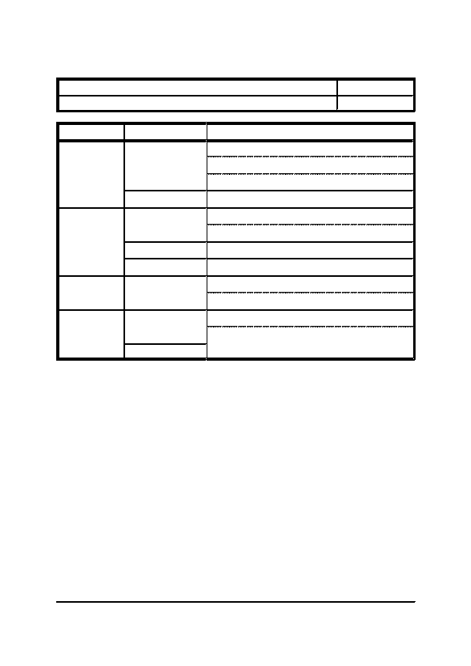
SECTION EIGHT

Title: Small Fan

Category: Miscellaneous Equipment

Symptom Possible Cause
Fault Tracing Charts
Item: 8.2.4

Page: 1 of 1
Electrical Supply
Not Running
Duty Low
Duty High
Drive Mechanism

Electrical Supply

Drive Mechanism

Resistance

Electrical Supply
Excessive Noise
Drive Mechanism

Damage
Checks

Check that electrical supply is available at fan.

Check local isolator is switched on.

Check controller is calling for fan to run.

Check motor is working.

Check for correct supply voltage.

Check for correct speed setting.

Check impeller is secure on shaft.

Check inlet and outlet of fan for obstruction.

Check for correct supply voltage.

Check for correct speed setting.

Check impeller is secure on shaft.

Check condition of motor.

Check impeller for impingement on casing.
General Office Building, Reception Refurbishment
Section 8, Page 11

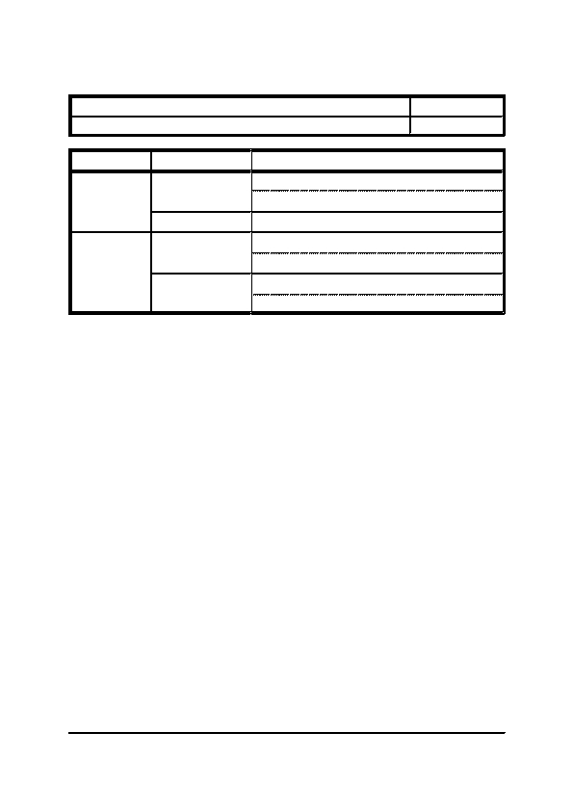
SECTION EIGHT

Title: Coil (DX)

Category: Miscellaneous Equipment

Symptom Possible Cause
Excessive
Cooling
Controls

Refrigerant

Controls
Fault Tracing Charts
Item: 8.2.5

Page: 1 of 1
Insufficient
Cooling
Refrigerant
Checks

Check for correct operation of thermostats and sensors.

Check for correct response at controller.

Check for correct operating pressure.

Check for correct operation of thermostats and sensors.

Check for correct response at controller.

Check for leaks in systems.

Check for correct operating pressure.
General Office Building, Reception Refurbishment
Section 8, Page 12

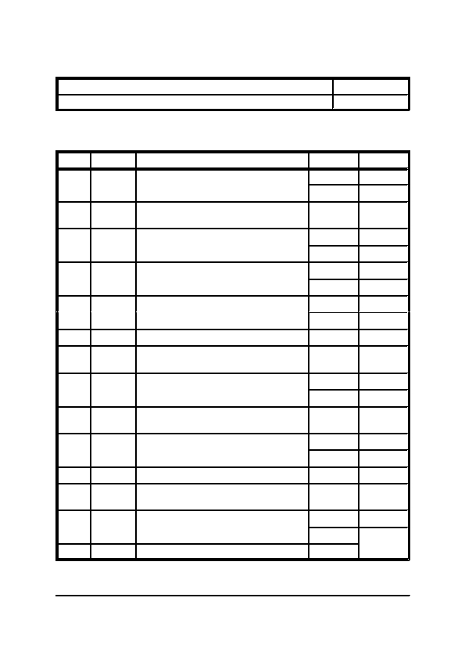
SECTION EIGHT

Title: Motor

Category: Miscellaneous Equipment
Fault Tracing Charts
Item: 8.2.6

Page: 1 of 6
The most common cause of faults that occur is due to motors of pumps or fans. This chart has therefore
been structured differently from the rest so as to lead not only to the cause but also to the remedy.
Step

1
Type

Test

Probable
Fault

Test
Details

Are all isolators switched on.
Answer

Yes

No

-

Yes

No

Yes

No

Yes

No

-

-

Yes

No

-

Yes

No

-

-

Yes

No

-
Go To Step

4

2

3

END

4

5

8

7

6

3

6

13

9

10

12

11

END

8

14 & 15

23

3
2
3
Switch isolators on.
Does motor start to run.
4
Test
Are any fuses ruptured.
5

6

7
8
Test

Action

Probable
Fault

Test
Are there any short circuits between phase to
neutral or phase to earth.

Replace ruptured fuses.

Repair short circuits.
Are all phase voltages satisfactory.

Check all phase voltages back to incoming
supply.

Are all phase voltages satisfactory at incoming
supply.

Refer to local electricity board.

Correct unsatisfactory voltage checking for
loose connections, etc.

Is starter tripped on a thermal overload
condition.

Reset the overload current.
9
Test
10

11

12
13

14
Test

Action

Probable
Fault

Test

Action
General Office Building, Reception Refurbishment
Section 8, Page 13

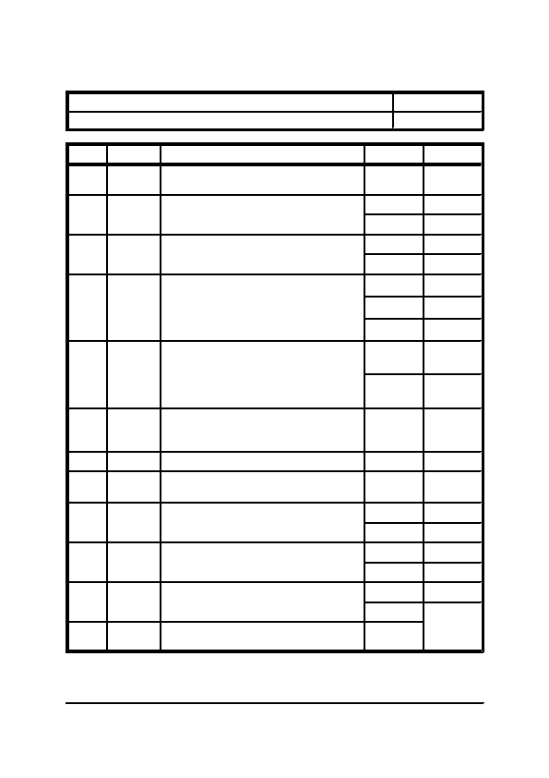
SECTION EIGHT

Title: Motor

Category: Miscellaneous Equipment
Step

15
Type

Action
Fault Tracing Charts
Item: 8.2.6

Page: 2 of 6
16
Test
Details

Measure the output current and voltage from
starter.

Are the voltages equal.
17
Test
18
Test
19
Action
20
21

22
Probable
Fault

Action

Action
23
Test
Are overloads set correctly.

Is the current consumed:-

1) Fractionally higher than motor rating.

2) Excessively higher than motor rating.

Set overload unit slightly higher and allow
motor to run for 15 minutes.

Does motor run satisfactory without
overheating.

Check that motor is not excessively
overloaded. If so reduce the loading so the
motor is operating to its designed conditions.

Adjust overload unit to correct setting.

Trace exactly where the voltage drop occurs
and remedy by cleaning contacts.

Is the starter equipped with a thermistor
protector.
Answer

-

Yes

No

Yes

No

-

Yes

Yes

Yes
Go To Step

16

17

22

18

21

-

19

20

END
No
20
-

-
13

13
24
Test
Is the thermistor protection tripped.
25
Test

Probable
Fault
26
Is the wiring of the thermistor and the
resistance of the thermistor circuit satisfactory.

Motor mounted thermistor may be burnt out or
wiring may be broken.
-

Yes

No

Yes

No

Yes

No

-
13

24

28

25

28

27

26

END
General Office Building, Reception Refurbishment
Section 8, Page 14

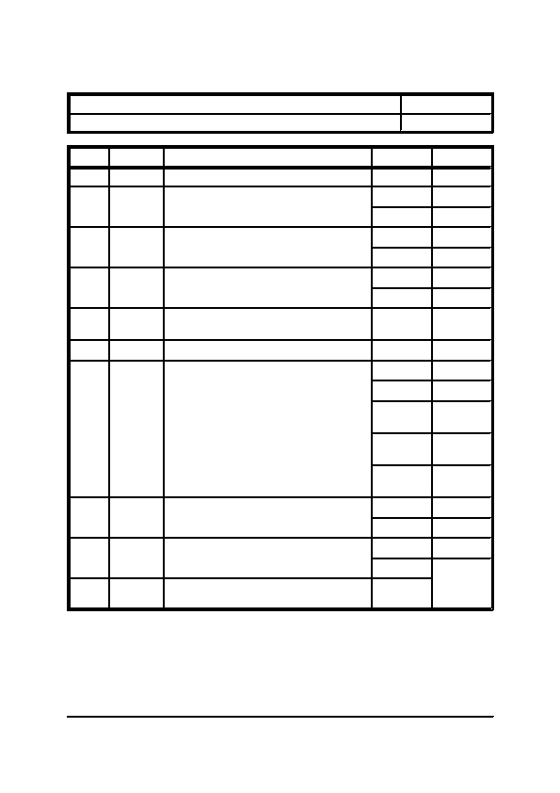
SECTION EIGHT

Title: Motor

Category: Miscellaneous Equipment
Step

27

28
Type

Action

Test
Details

Reset thermistor protector unit.

Is the starter equipped with an earth leakage
protector circuit.
Fault Tracing Charts
Item: 8.2.6

Page: 3 of 6
29
Test
Is the earth leakage protector tripped.
30
Test

Probable
Fault

Action
Is the an earth leakage fault or any wiring fault
on the earth leakage circuit.

Earth Leakage.

Reset earth leakage protector unit.
Answer

-

Yes

No

Yes

No

Yes

No

-

-

D.O.L.

A.S.D.

Stator
Rotor

Auto-
Trans

Vapour-
matic

Yes

No

Yes

No

-
Go To Step

3

29

33

30

33

31

32

END

3

34

37

41
31

32
33
Test
What type of starter is used.
34
Test
Does the starter contactor operate.
35
Test

Probable
Fault
Is there any voltage across the contactor coil
terminals.

Contactor coil burnt out.
44
34

47

35

36

48

END
36
General Office Building, Reception Refurbishment
Section 8, Page 15

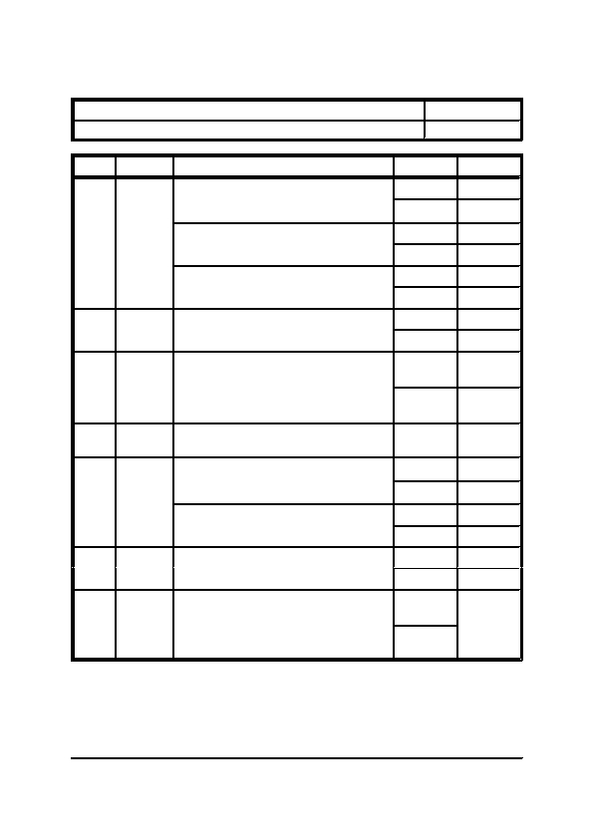
SECTION EIGHT

Title: Motor

Category: Miscellaneous Equipment

Step Type
Fault Tracing Charts
Item: 8.2.6

Page: 4 of 6
37
Test
Details

Do the starter contactors operate:-

Main Contactor

Star Contactor
Delta Contactor
38
Test
39
Test
40
Probable
Fault
41
Test
Is there any voltage across the contactor coil
terminals.

Check timer unit for correct action
remembering when initially started the Star
and Main Contactors should be energised and
at the end of the time period the Delta and
Main Contactors should be energised.

Timer unit may be faulty or wiring associated
may be faulty

Do the starter contactors operate:-

Main Contactor

Subsidiary Contactors
Answer

Yes

No

Yes

No

Yes

No

Yes

No

Correct
Go To Step

39

35

39

38

39

38

36

39

49
Incorrect
40
42
Test
43
Test
Is there any voltage across the contactor coil.

Check timing circuits for correct action
remembering when initially started the Main
Contactor should be energised and at the end
of each time period a subsidiary contactor will
also be energised, until all are energised.
-

Yes

No

Yes

No

Yes

No

Correct
END

43

35

43

42

36

43

49
Incorrect
40
General Office Building, Reception Refurbishment
Section 8, Page 16

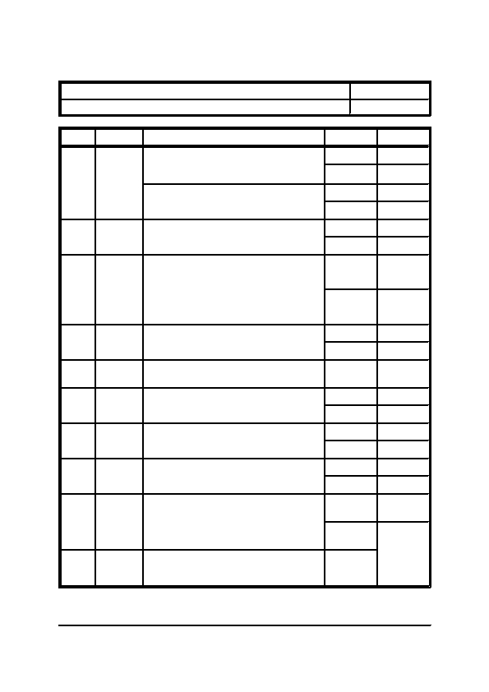
SECTION EIGHT

Title: Motor

Category: Miscellaneous Equipment

Step Type
Fault Tracing Charts
Item: 8.2.6

Page: 5 of 6
44
Test
Details

Do the starter contactors operate:-

Main Contactor

Subsidiary Contactors
45
Test
46
Test
47
Test

Probable
Fault

Test
Is there any voltage across the contactor coil
terminals.

Check timing circuits for correct action
remembering when initially started the Star
and Load Contactors should be energised and
at the end of the time period the Run Contactor
should be energised whilst the Star and Load
Contactors should be de-energised.

Check the control action of the starter.

Control circuit wiring of the started may be
faulty.

Are the motor windings open circuit.
Answer

Yes

No

Yes

No

Yes

No

Correct
Go To Step

46

35

46

45

36

46

49
Incorrect

Correct

Incorrect

-

Yes

No

Yes

No

Yes

No

Satis-
factory

Not Satis-
factory
40

49

48

END

53

50

51

53

52

53

56
48
49
50
Test
Are the motor windings of equal resistance.
51
Test
Is there continuity through all the contactors
when contacts are closed.
52
Test
53
Probable
Fault
Is the wiring between the starter and the motor
satisfactory, i.e. are there any breakages or
high resistances.

Any one of the motor windings being open
circuit or of different resistance would result in
an unbalance load.
55
-
END
General Office Building, Reception Refurbishment
Section 8, Page 17

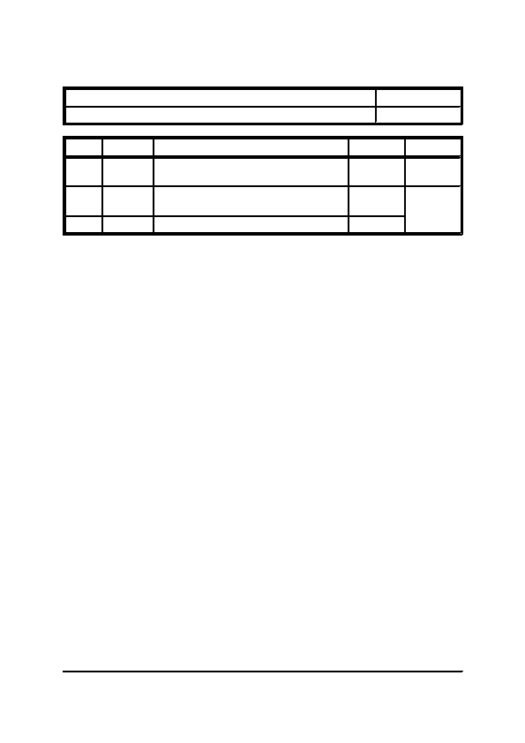
SECTION EIGHT

Title: Motor

Category: Miscellaneous Equipment
Step

54
Fault Tracing Charts
Item: 8.2.6

Page: 6 of 6
55

56
Type

Probable
Fault

Probable
Fault

-
Details

Discontinuity through contacts would not
allow the motor to run.

Broken wiring or high resistance wiring would
result in an unbalance load.

Problem not found - Go back to Step 1.
Answer

-
Go To Step

END
-

-
END

1
General Office Building, Reception Refurbishment
Section 8, Page 18


SECTION NINE
MANUFACTURERS' LITERATURE


SECTION NINE

INDEX

ITEM
9.1

9.1.1
9.1.2
-

-
-
Manufacturers' Literature
DESCRIPTION

MANUFACTURERS' LITERATURE

Mitsubishi Electric Europe Ltd PEAD-RP Internal Air Conditioning Unit
Mitsubishi Electric Europe Ltd PUHZ-RP External Air Conditioning Unit
General Office Building, Reception Refurbishment
Section 9, Page 2


SECTION TEN
TEST CERTIFICATES AND COMMISSIONING DATA


SECTION TEN

INDEX

ITEM
10.1

10.1.1
10.1.2
10.1.3
-

-
-
-
Test Certificates and Commissioning Data
DESCRIPTION

HEATING AND COOLING SYSTEMS

Refrigeration Pipework Pressure Test Certificate
Air Conditioning System Commissioning Report
Condensate Pipework Flood Discharge Test Certificate
General Office Building, Reception Refurbishment
Section 10, Page 2


SECTION ELEVEN
SPECIALIST SERVICES DOCUMENTATION


SECTION ELEVEN

CONTENTS

ITEM
11.1

11.1.1
-

-
Specialist Services Documentation
DESCRIPTION

SPECIALIST SERVICES DOCUMENTATION

A N Other Controls Company Ltd Mechanical Services Control System
General Office Building, Reception Refurbishment
Section 11, Page 2


SECTION TWELVE
RECORD DRAWINGS


SECTION TWELVE

INDEX

ITEM
12.1

12.1.1
-

-
Record Drawings
DESCRIPTION

RECORD DRAWINGS

Schedule of Record Drawings
General Office Building, Reception Refurbishment
Section 12, Page 2


SECTION TWELVE

Title: Schedule of Record Drawings

Category: Record Drawings
Number

RD01
RD02
Size

A1
A1
Record Drawings
Item: 12.1.1

Page: 1 of 1
Title

Ground Floor Reception Mechanical Services Layout
Roof Level Mechanical Services Layout
General Office Building, Reception Refurbishment
Section 12, Page 3

